LOGISTICS DATA ANALYST INTERNSHIP — STRATEGIC PLANNING REPORT
Intelligent Logistics Performance Analytics and Delivery Optimization System
Week 1: Strategic Planning, Data Architecture, and Machine Learning Methodology

A strategic planning and technical architecture report establishing an analytical decision-support framework for multi-modal freight operations, transit duration prediction, route risk segmentation, and prescriptive linear cost optimization.

Table of Contents
Part I: Strategic Context, Business Case & Governance Pages 4 – 12
1. Strategic Project Overview 4
2. Introduction & Logistics Operational Complexity 5
3. Industry and Business Context 6
4. Project Definition and Business Case 7
5. Multi-Regional Logistics Business Scenario 7
6. Formal Problem Statement & Analytical Problems 9
7. Strategic Project Objectives and Analytical Questions 9
8. Project Scope, Assumptions and Boundaries 11
9. Stakeholder and Decision Framework 12
Part II: Performance Architecture & Data Foundation Pages 13 – 21
10. KPI and Performance Measurement Framework 13
11. Data Research and Data Requirements 15
11.1 Public Data Resources and Dataset Feasibility 18
12. Data Quality and Governance Strategy 21
Part III: Data Science Methodology & System Architecture Pages 22 – 25
13. Analytical Strategy and Data Science Methodology 22
14. Regression Modeling Strategy (Transit Duration Forecasting) 23
15. Classification Strategy (Pre-Dispatch Delay Risk) 24
16. Clustering and Segmentation Strategy (Corridor Profiling) 24
17. Optimization and Prescriptive Analytics Strategy 25
Part IV: Analytical Protocols, Technology & Python Blueprints Pages 26 – 39
18. End-to-End Analytical Lifecycle 26
19. Proposed Enterprise Analytics Architecture 28
20. Data Collection and Integration Strategy 29
21. Data Preparation Strategy & Hygiene Pipeline 29
22. Exploratory Data Analysis (EDA) Strategy 30
23. Feature Engineering Strategy 31
24. Predictive Modeling Blueprint & Validation Framework 31
25. Python Technology and Implementation Environment 32
26. Python Implementation Blueprints (Modules A – H) 33
Part V: Execution Roadmap, Business Value & Governance Pages 40 – 44
27. Implementation Roadmap & Milestones 40
28. Success Criteria and Evaluation Framework 41
29. Expected Business Outcomes 41
30. Risks, Limitations and Mitigation Strategy 42
31. Conclusion and Next-Phase Transition 43
32. Formal Academic References & Industry Literature 43
33. Appendix: Mathematical Nomenclature & Symbol Glossary 44

List of Figures
Figure 1: Logistics Analytics Problem Landscape & Systemic Relationships 6
Figure 2: Multi-Tiered Logistics KPI Hierarchy Framework 13
Figure 3: Analytics Maturity Framework: Descriptive to Decision Intelligence 22
Figure 4: Analytical Methodology to Operational Decision Map 24
Figure 5: End-to-End Enterprise Logistics Analytics Lifecycle 26
Figure 6: Proposed 4-Tier Intelligent Logistics System Architecture 28
Figure 7: Phased Internship Implementation Roadmap & Milestones 40

List of Tables
Table 1: Document Control & Administrative Metadata 1
Table 2: Business Problem Statement & Analytical Opportunity Matrix 7
Table 3: Multi-Modal Transportation Fleet Operational Profiles 8
Table 4: Stakeholder-to-Decision Responsibility & Value Matrix 12
Table 5: Comprehensive Enterprise Logistics KPI Performance Scorecard 13
Table 6: Comprehensive Logistics Data Dictionary & Schema Specification 16
Table 6A: Public Logistics Data Resources & Dataset Feasibility Matrix 18
Table 7: Data Quality Assessment & Remediation Matrix 21
Table 8: Supervised Regression Modeling Strategy & Algorithm Blueprint 23
Table 9: End-to-End Analytics Lifecycle Phase Specifications 26
Table 10: Exploratory Data Analysis (EDA) Planning Matrix (Plotly Framework) 30
Table 11: Python Analytics & Machine Learning Technology Stack 32
Table 12: Phased Implementation Timeline & Governance Gates 40
Table 13: Multi-Dimensional Project Success Evaluation Scorecard 41
Table 14: Enterprise Risk Register & Strategic Mitigation Framework 42
Table 15: Mathematical Optimization Nomenclature & Symbol Glossary 44

1. Strategic Project Overview
Planning Assumptions & Methodological Context Note
Methodological Context Note: Any numerical baseline values, historical performance percentages, operating expenditure estimates, and target improvement thresholds presented throughout this Week 1 report represent hypothetical planning assumptions designed solely to construct a realistic, rigorous operational business case. They do not represent empirical results derived from a completed dataset analysis, as Week 1 represents the strategic planning, research, and architectural design phase. Actual baseline distributions, empirical model parameters, and verified financial outcomes will be established systematically in subsequent data ingestion and analytical phases (Weeks 2 through 4).

Commercial freight distribution networks operate at the intersection of narrow operating margins, tight delivery appointments, and volatile transportation expenditures. Across our modeled scenario of five operational territories and twelve central cross-dock distribution hubs, the enterprise coordinates over 15,000 consignments each week across four transport modes: Express Air, Dedicated Full Truckload (FTL), Less-Than-Truckload (LTL), and Intermodal Rail. In recent quarters, operational leadership has observed a persistent decline in delivery reliability. Under our modeled planning baseline, the network-wide On-Time Delivery Rate has fallen to approximately 81.4%, with acute congestion corridors in the Northeast and Pacific West experiencing delay rates exceeding 24%. Concurrently, average transportation expenditures per shipment have increased by an assumed 18.2%, driven by emergency spot-market carrier bookings, expedited modal upgrades, and uncoordinated dispatching schedules.
These compounding operational challenges stem directly from a structural reliance on reactive management. Regional dispatchers currently rely on static transit lookup tables, disconnected spreadsheets, and historical billing reconciliations. Delays are frequently identified only after receiving facilities log missed-appointment exception tickets. Transportation modes are often selected based on local habits rather than global network cost-velocity trade-offs. Furthermore, line-haul tractors frequently operate at sub-optimal load factors (averaging an estimated 64.8% cube utilization) while accumulating uncompensated empty backhaul miles returning from inland consumer markets to coastal manufacturing gateways.
Strategic Project Rationale & Decision Intelligence Vision
Logistics operational performance cannot be sustainably improved through fragmented local adjustments or manual rules of thumb. Delivering tangible margin expansion and SLA reliability requires a centralized, data-driven analytical framework that combines predictive transit duration forecasting, unsupervised route risk profiling, and prescriptive linear programming cost optimization. This system moves operational decision-making from reactive problem-solving toward earlier, data-supported intervention.

This technical planning report establishes the architectural and mathematical foundation for the Intelligent Logistics Performance Analytics and Delivery Optimization System. Developed as the primary deliverable for Week 1 of the Logistics Data Analyst Internship, this document details the operational business case, establishes an enterprise Key Performance Indicator (KPI) framework, specifies data hygiene protocols across seventeen core variables, evaluates public data resources, details data science methodologies spanning regression, classification, clustering, and linear programming, and provides eight modular Python blueprints using Plotly for interactive visualization. As a planning document, all models, pipelines, and performance metrics represent empirical benchmarks and architectural designs that directly prepare the project for Week 2 (Data Collection and Cleansing), Week 3 (Exploratory Analysis and Dashboarding), and Week 4 (Predictive Modeling and Optimization).
2. Introduction & Logistics Operational Complexity
Modern supply chains have evolved from straightforward transportation pipelines into complex, stochastic physical and digital networks. In an economy characterized by omnichannel commerce, tight manufacturing schedules, and strict On-Time, In-Full (OTIF) vendor mandates, delivery reliability serves as a primary commercial differentiator. However, managing line-haul freight across geographically diverse regions introduces deep operational complexity governed by compounding sources of variance:
• Transit Duration Stochasticity: Highway transit duration is inherently non-deterministic. Mountain pass elevation, variable urban congestion, highway construction bottlenecks, and regional weather fronts create heavy-tailed transit time distributions that break static mileage-based transit tables.
• Driver Hours-of-Service (HOS) Friction: Commercial vehicle operations face hard legal constraints, including strict driver Hours-of-Service (HOS) electronic logging mandates (11 hours driving limit within a 14-hour duty window). A two-hour traffic bottleneck can force a mandatory 10-hour driver rest period, turning a minor delay into a full 24-hour delivery failure.
• Volumetric Density Balancing: Freight economics are dictated by the interplay between weight capacity (weigh-out) and cubic volume capacity (cube-out). Dispatchers who lack real-time payload analytics dispatch trailers that are physically full but under-weight, or fully weighted with substantial unused cubic capacity.
• Demurrage and Delivery Window Penalties: Major retail distribution centers enforce strict delivery appointment windows (typically 2 to 4 hours). Arriving outside this allocated window results in refused loads, detention penalties ($75 to $150 per hour), and carrier compliance chargebacks.
Historical reporting and isolated spreadsheets are fundamentally incapable of modeling these dynamic dependencies. When analytics is confined to post-hoc reporting, leadership only discovers that a corridor is unprofitable weeks after freight has moved. Managing modern supply chain operations requires shifting from retrospective reporting to forward-looking predictive and prescriptive intelligence.
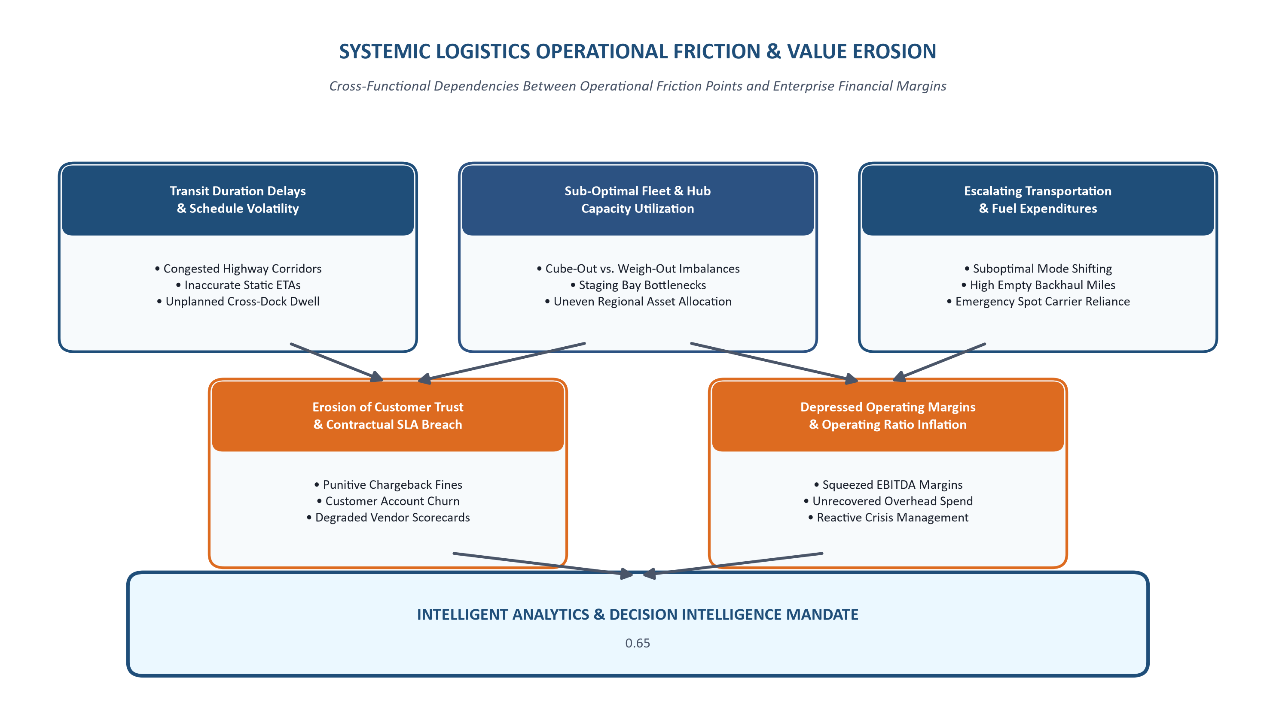
Figure 1: Logistics Analytics Problem Landscape & Systemic Relationships
3. Industry and Business Context
The North American and global freight transportation landscape is experiencing economic and structural pressures that directly frame this project:
Fuel Volatility and Operating Ratio Compression: Diesel fuel expenditures typically account for 28% to 35% of total line-haul operating expenditures. Fluctuations in the U.S. Energy Information Administration (EIA) diesel price index, coupled with newly enacted regional carbon offset regulations, have compressed carrier operating margins. In this tight economic climate, freight networks can no longer absorb uncompensated empty miles (deadhead transit), which under our planning scenario account for an estimated 16.5% of total fleet mileage.
The Strict 'On-Time, In-Full' (OTIF) Mandate: Enterprise shippers (such as major retail and e-commerce distribution platforms) enforce strict delivery compliance standards. Under modern OTIF vendor compliance programs, suppliers face financial penalties of up to 3% of the purchase order value for shipments delivered outside allocated windows. For a commercial freight carrier, failing to maintain an On-Time Delivery Rate above 95% triggers direct financial chargebacks and threatens multi-year dedicated carriage contracts.
Scope 3 Decarbonization and Modal Migration: Shippers are under increasing corporate mandates to report and reduce Scope 3 greenhouse gas emissions. Optimizing multi-modal freight allocation—shifting eligible bulk freight from long-haul road carriage to intermodal rail—can reduce carbon emissions by up to 65% per ton-kilometer while lowering direct line-haul expenditures.
4. Project Definition and Business Case
The Intelligent Logistics Performance Analytics and Delivery Optimization System is an enterprise analytics framework designed to consolidate multi-modal shipping manifests, audit data quality, diagnose operational bottlenecks, predict delivery transit times, group high-risk corridors, and generate cost-minimized dispatch plans. The business case centers on transitioning from fragmented manual dispatching to an integrated analytical decision engine.
Table 2: Business Problem Statement & Analytical Opportunity Matrix
Operational Dimension | Current Operating Challenge (Assumed) | Proposed Analytical Response | Modeled Target Value (Planning Goal)
Line-Haul Schedule Reliability | Network OTD% at ~81.4%; chronic customer service disputes and SLA breaches. | Supervised machine learning (Random Forest / LightGBM) to forecast transit duration and delay risk. | Target network OTD% ≥ 95.0%; eliminate chargeback penalties.
Freight Expense Control | Transportation spend increased ~18.2% YoY due to emergency air freight and spot carriers. | Prescriptive Linear Programming (PuLP) for multi-modal cost-capacity allocation. | Target 8% – 14% direct transport cost savings (~$7.4M annual EBITDA potential).
Fleet Capacity Utilization | Trailers operating at ~64.8% average volume capacity; deadhead mileage at ~16.5%. | Feature engineering of density ratios; linear load consolidation constraints. | Target load factor ≥ 85%; reduce empty miles by 15%.
Route-Level Risk Management | Lack of forward-looking visibility into severe weather and mountain corridor delays. | Unsupervised K-Means clustering to segment lanes into four operational risk profiles. | Tailor lane pricing, driver scheduling, and proactive weather rerouting.
Enterprise Data Governance | Data siloed across TMS, WMS, and billing; missing sensor logs and dirty datetimes. | Standardized schema validation, IQR outlier fences, and centralized Parquet storage. | 100% schema compliance; single source of operational truth.

5. Multi-Regional Logistics Business Scenario
To ensure that all models and methodologies address operational realities, the project models an enterprise multi-modal freight network operating across five distinct geographic zones connected by twelve central hub distribution terminals:
• Zone 1 (Northeast Corridor): Dense urban transit corridors, heavy toll bridge networks, severe peak-hour highway congestion, strict municipal night-delivery curfews (Hubs: Newark, Boston, Philadelphia).
• Zone 2 (Midwest Manufacturing Belt): Heavy manufacturing freight, extensive interstate connectivity (I-80, I-90), acute winter freeze disruptions and lake-effect snowstorms (Hubs: Chicago, Detroit, Cleveland).
• Zone 3 (Southeast / Gulf Coast): Rapidly growing e-commerce fulfillment centers, high agricultural and cross-border freight, extreme summer operating temperatures (Hubs: Atlanta, Dallas, Memphis).
• Zone 4 (Central Mountain Corridor): Long-haul interstate freight, high elevation mountain passes (I-70 Rockies), sparse terminal networks, high seasonal chain-control closures (Hubs: Denver, Salt Lake City).
• Zone 5 (Pacific West Maritime): Intermodal maritime import drayage, high labor costs, strict regional zero-emission drayage truck mandates (Hubs: Los Angeles, Seattle).
The fleet manages freight flows across four operational transport modes, each characterized by distinct cost structures, velocity parameters, and payload limits (modeled as representative industry planning benchmarks):
Table 3: Multi-Modal Transportation Fleet Operational Profiles (Planning Benchmarks)
Transportation Mode | Distance Band (KM) | Cost / KM ($) [Est.] | Average Velocity | Payload Limit (KG) | Target Commodity / SLA Window
Express Air Freight | 800 – 3,500 KM | $4.50 – $8.20 | 650 – 850 km/h | 5,000 KG | High-value pharmaceuticals, electronics, critical next-day parts
Dedicated Full Truckload (FTL) | 300 – 2,500 KM | $1.85 – $2.75 | 65 – 85 km/h | 22,000 KG | Direct terminal-to-terminal shipments, single-shipper full loads
Less-Than-Truckload (LTL) | 100 – 1,200 KM | $1.20 – $1.95 | 45 – 65 km/h | 8,000 KG | Multi-client consolidated palletized freight, regional spoke routes
Intermodal Rail Freight | 1,000 – 4,000 KM | $0.65 – $1.15 | 35 – 50 km/h | 65,000 KG | Heavy non-urgent raw materials, cross-country container moves

6. Formal Problem Statement & Analytical Problems
Primary Problem Statement
The enterprise multi-modal logistics network currently experiences an unacceptably high delivery delay rate (~18.6% network baseline assumption), escalating transportation operating expenses ($185 average cost per shipment assumption), and sub-optimal asset utilization (~64.8% average volumetric load factor). These operational inefficiencies result from fragmented, reactive dispatch decision-making, a lack of pre-dispatch predictive transit visibility, and an absence of mathematical network optimization across modes and corridors.
Supporting Analytical Research Questions
To decompose this business challenge into rigorous, actionable analytical workstreams, five core research questions are formulated:
• Research Question 1 (Delay Attribution): What are the primary drivers of transit delay variance? What relative weights do distance, gross payload weight, volumetric cube, transportation mode, origin hub congestion, and regional weather risk contribute to SLA breaches?
• Research Question 2 (Lane Inefficiency Isolation): Which specific origin-destination lanes and geographic hubs exhibit chronic, structural delay patterns rather than temporary operational anomalies?
• Research Question 3 (Predictive Transit Forecasting): Can a supervised machine learning regression pipeline predict continuous elapsed delivery duration with a Mean Absolute Error (MAE) under 2.5 hours prior to vehicle dispatch?
• Research Question 4 (Operational Segmentation): Can unsupervised clustering algorithms (K-Means / Agglomerative) segment thousands of disparate delivery routes into distinct, operationally homogeneous risk archetypes to enable differentiated pricing and SLA commitments?
• Research Question 5 (Prescriptive Network Optimization): How can machine-learning predicted transit durations be combined with prescriptive linear programming solvers to minimize total network transport costs while satisfying strict vehicle capacity, hub throughput, and customer SLA constraints?
7. Strategic Project Objectives and Analytical Questions
Strategic Project Objectives (SMART)
• OBJ-1 (Data Engineering & Hygiene): Develop an automated Python data ingestion, schema validation, and cleaning pipeline achieving 100% type enforcement and eliminating unhandled nulls across all seventeen core shipping variables.
• OBJ-2 (Performance Measurement): Build an enterprise KPI calculation engine that continuously computes five primary metrics (OTD%, ADT, TCPS, DDR%, CPKM) and five secondary operational ratios across all operational territories.
• OBJ-3 (Diagnostic Discovery): Execute multi-variable exploratory data analysis using interactive Plotly visualizations to quantify statistical dependencies between consignment attributes and delivery delay frequencies.
• OBJ-4 (Predictive Duration Modeling): Train, benchmark, and validate supervised machine learning regression models (Random Forest, Gradient Boosting) to forecast shipment delivery transit duration within an MAE threshold of 2.50 hours.
• OBJ-5 (Pre-Dispatch Delay Risk Classification): Develop a supervised binary classification pipeline that estimates pre-dispatch delay probabilities, targeting a classification precision of ≥ 80% and ROC-AUC of ≥ 0.88.
• OBJ-6 (Unsupervised Route Segmentation): Deploy unsupervised K-Means clustering to partition the multi-regional route network into four distinct operational risk profiles, targeting a Silhouette Coefficient ≥ 0.55.
• OBJ-7 (Prescriptive Optimization): Formulate and solve a multi-modal Linear Programming optimization model in PuLP that targets direct line-haul cost reductions between 8% and 14% subject to fleet capacity and SLA constraints.
Core Analytical Questions Matrix
Operational Inquiries: The following specific analytical inquiries guide our technical exploratory and modeling phases:
• AQ-1: What is the exact correlation coefficient between shipment weight and cost-per-kilometer across FTL versus LTL modes?
• AQ-2: At what specific distance threshold does Intermodal Rail become more cost-effective than Dedicated FTL while still meeting standard 72-hour SLAs?
• AQ-3: How severely does cross-dock dwell duration at origin terminals inflate total elapsed transit time?
• AQ-4: What proportion of total delivery delays is attributable to weekend dispatch surges versus mid-week line-haul bottlenecks?
• AQ-5: Does volumetric cube-out or gross payload weigh-out represent the primary binding capacity constraint on line-haul tractors?
• AQ-6: Which regional distribution hubs demonstrate the highest variance between promised customer lead times and actual arrival timestamps?
• AQ-7: Can non-linear tree-based ensembles significantly outperform classical Ordinary Least Squares (OLS) regression in transit duration estimation?
• AQ-8: What is the optimal classification decision threshold that maximizes delay recall without overburdening dispatchers with false alarms?
• AQ-9: How sensitive is total network transportation cost to a 10% increase in regional diesel fuel surcharge rates?
• AQ-10: What are the operational characteristics of the top 5% most expensive freight corridors in the national network?
8. Project Scope, Assumptions and Boundaries
In-Scope Technical and Analytical Boundaries
• Data Scope: Multi-modal shipment manifest data spanning twelve central hubs, five operational regions, and four transport modes.
• Preprocessing Scope: Programmatic data hygiene, missingness imputation, IQR outlier fences, datetime standardization, and automated schema enforcement.
• Exploratory Scope: Univariate distributions, bivariate cross-tabulations, interactive Plotly correlation heatmaps, modal cost benchmarking, and regional performance disparity analysis.
• Modeling Scope: Feature engineering, TimeSeriesSplit experimental design, supervised regression (transit duration), supervised classification (delay risk), unsupervised clustering (corridor segmentation), and linear programming cost optimization.
• Deliverable Scope: Modular Python script blueprints, interactive Plotly dashboard components, risk registers, and business impact models.
Out-of-Scope Boundaries
• Telematics Hardware: Direct physical maintenance, firmware flashing, or hardware installation of GPS telematics units on commercial vehicles.
• Live Production ERP Writes: Destructive schema migrations or direct database write-backs to production transactional ERP / TMS databases.
• Customs Regulatory Filings: International customs tariff negotiations, maritime bill-of-lading filings, or cross-border trade legal compliance.
• Physical Warehouse Automation: Automated robotic material-handling or autonomous forklift automation within cross-dock warehouse facilities.
Operational Assumptions and Constraints
• Assumption 1: Historical shipment timestamps in the staging dataset accurately reflect the physical moment trailers cleared terminal exit gates.
• Assumption 2: Transportation costs recorded in manifests include direct line-haul, driver labor, fuel surcharges, and highway tolls.
• Assumption 3: Commercial vehicles strictly adhere to federal electronic logging device (ELD) hours-of-service regulations (maximum 11 hours daily driving).
• Constraint 1: Line-haul vehicle fleet capacity is finite and bounded by modal availability across designated regional hub locations.
9. Stakeholder and Decision Framework
An advanced data analytics framework delivers operational value only when its analytical outputs directly support specific decisions. The table below maps stakeholder groups to their decision responsibilities, required analytical insights, and operational benefits:
Table 4: Stakeholder-to-Decision Responsibility & Value Matrix
Stakeholder Group | Core Decision Responsibility | Required Analytical Insight | Analytics / KPI Support | Expected Operational Benefit
Logistics Operations Managers | Daily line-haul dispatching, cross-dock throughput, carrier assignment | Corridor delay bottlenecks, predicted transit times, hub congestion forecasts | Delay Rate (DDR%), ADT, Delay Risk Classifier Output | Proactively reroute at-risk consignments; reduce cross-dock yard congestion.
Fleet & Dispatch Coordinators | Trailer loading schedules, driver routing, mode selection per order | Payload density ratios, dynamic route risk scores, ETA predictions | CUR% (Load Factor), Route Circuity Ratio, Regression ETA | Improve vehicle cube utilization; avoid dispatching into severe storm fronts.
Chief Supply Chain Officer (CSCO) | Multi-year carrier contracts, hub location strategy, capital allocation | Cross-regional SLA compliance, modal cost disparities, long-term trends | Network OTD%, Total Freight Spend vs. Budget, RPDI | Negotiate data-backed carrier tariffs; optimize terminal network footprint.
Corporate Finance & Accounting | Freight billing audit, fuel surcharge validation, chargeback defense | Cost per KM breakdowns, delay chargeback reconciliations, margin leaks | TCPS, CPKM, Delay Penalty Reconciliation Scorecard | Identify erroneous carrier billing; defend against disputed penalty charges.
Customer Service Directors | Shipper satisfaction, delivery transparency, customer exception handling | Accurate pre-dispatch arrival windows, root-cause delay attribution | Predicted Arrival Windows, Delay Status Exception Alerts | Reduce inbound shipment status inquiries; improve customer satisfaction.
Warehouse Operations Leads | Inbound dock scheduling, cross-dock staging labor allocation | Line-haul trailer arrival schedules, cargo volume surges, payload specs | Inbound Arrival Schedules, Volume Throughput (SVT) | Reduce tractor detention fees; align staging labor with expected arrivals.
Data Science & BI Team | Model accuracy governance, feature store maintenance, pipeline health | Data pipeline latency, model prediction drift (PSI), feature importance | Pipeline Quality Score, RMSE, MAE, ROC-AUC, Silhouette Score | Maintain reliable analytical pipelines and prevent model degradation.

10. KPI and Performance Measurement Framework
An enterprise logistics performance measurement framework requires a balanced, multi-dimensional scorecard. Evaluating logistics operations purely on cost can compromise service quality, while optimizing solely for velocity triggers unsustainable carrier expenses. We establish a hierarchical KPI architecture structured into Strategic, Tactical, and Operational tiers:
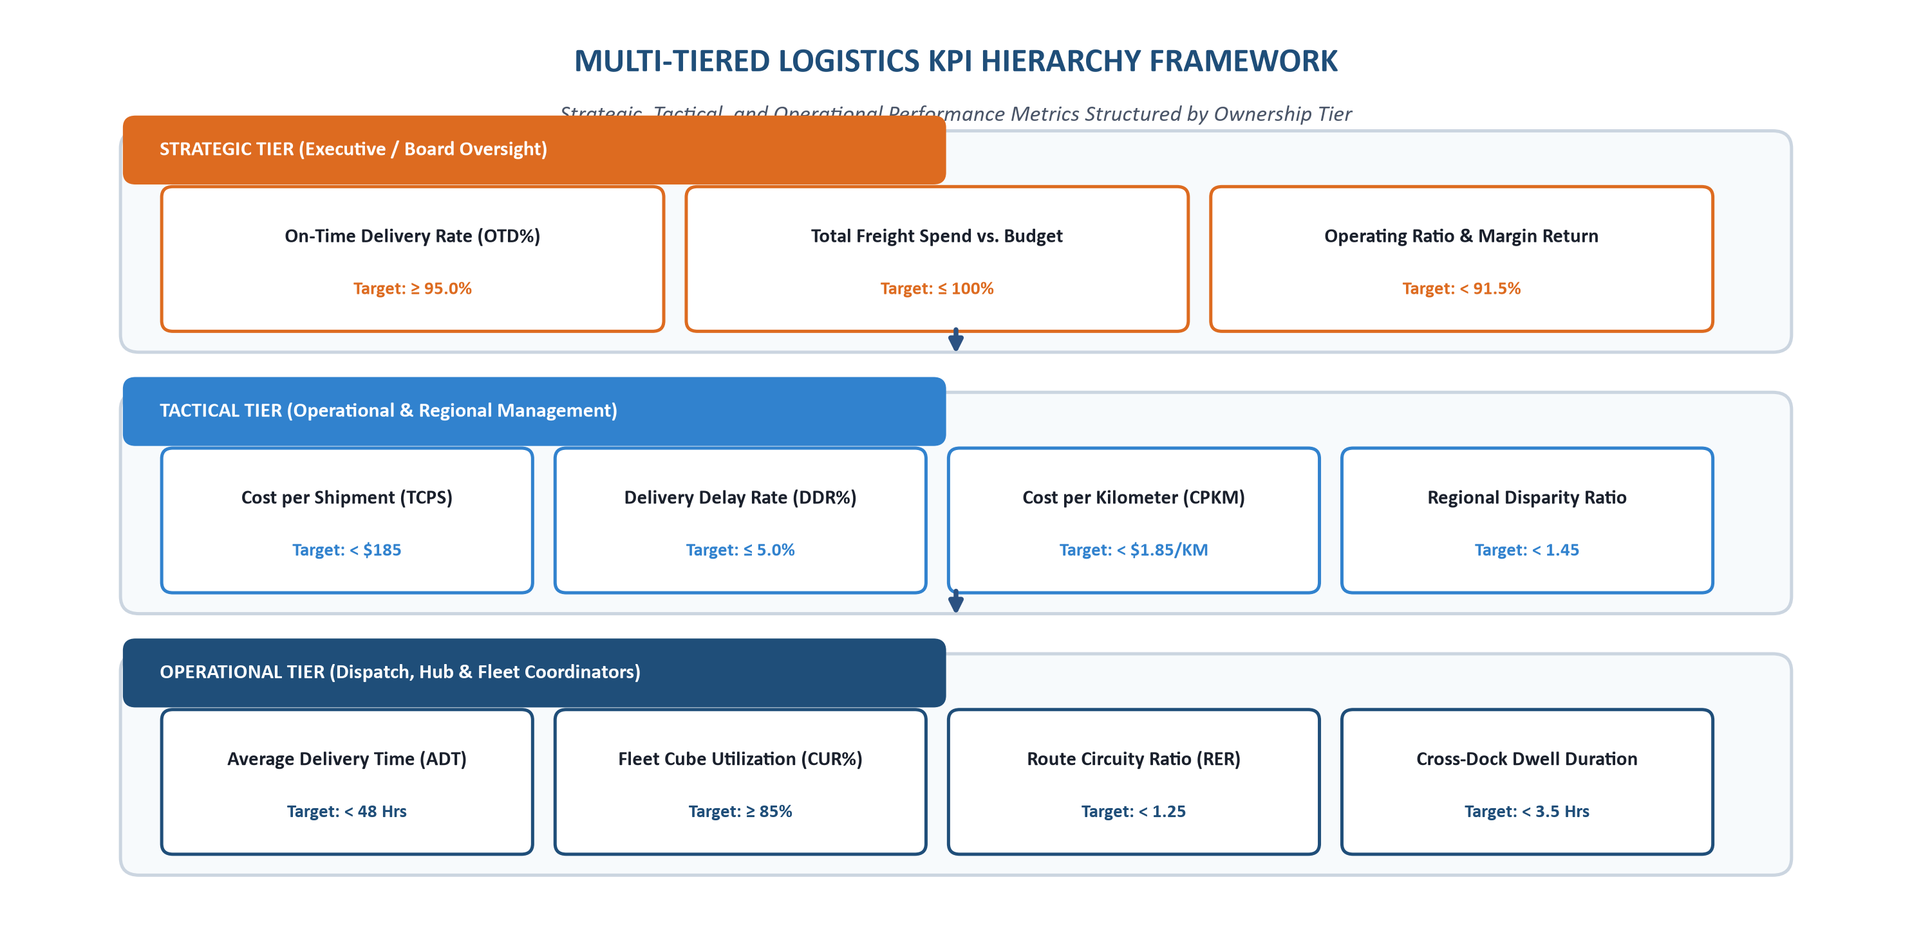
Figure 2: Multi-Tiered Logistics KPI Hierarchy Framework
The table below defines our comprehensive ten-metric KPI framework, complete with exact mathematical formulations, calculation parameters, planning benchmarks, reporting cadences, and operational decision owners:
Table 5: Comprehensive Enterprise Logistics KPI Performance Scorecard
Metric Name & Tier | Mathematical Formulation & Variables | Target Planning Benchmark | Cadence & Owner | Business Significance & Decision Value
On-Time Delivery Rate (OTD%)  [Strategic KPI-1] | OTD% = (N_ontime / N_total) × 100  Num: Shipments with Actual ≤ Promised  Denom: Total Dispatched Shipments | ≥ 95.0% Target  (Industry Benchmark: ≥ 98%) | Daily / Weekly  CSCO & Ops Dir | Primary indicator of customer service reliability. Determines contract renewals and prevents contractual SLA chargebacks.
Total Freight Spend Ratio  [Strategic KPI-2] | TFSR = (Actual_Freight_Spend / Budgeted_Spend) × 100  Num: Total Freight Expenditures ($)  Denom: Approved Freight Budget ($) | ≤ 100.0% Target  (Variance < 2%) | Monthly  Finance Manager | High-level budget compliance. Flags unbudgeted carrier rate spikes and emergency expediting expenses.
Transportation Cost / Shipment (TCPS)  [Tactical KPI-3] | TCPS = Total_Transportation_Cost / N_total  Num: Line-haul, fuel, and toll spend  Denom: Total delivered consignments | < $185.00 Target  (Planning Goal: 10% cut) | Weekly  Logistics Manager | Primary unit economics metric. Reflects direct operational efficiency and modal selection effectiveness.
Delivery Delay Rate (DDR%)  [Tactical KPI-4] | DDR% = (N_delayed / N_total) × 100  Num: Shipments with Actual > Promised  Denom: Total delivered shipments | ≤ 5.0% Target  (Action Level: > 12%) | Daily / Shift  Dispatch Supervisor | Direct inverse of OTD%. Automatically triggers operational exception reviews and carrier performance audits.
Cost per Kilometer (CPKM)  [Tactical KPI-5] | CPKM = Total_Transportation_Cost / Total_KM  Num: Total line-haul expenditure ($)  Denom: Total line-haul distance (KM) | $1.45 – $1.85 / KM  (Blended Network Model) | Weekly  Carrier Contract Lead | Distance-normalized cost efficiency. Isolates lanes with unfavorable carrier tariffs, high tolls, or deadhead miles.
Regional Disparity Ratio (RPDI)  [Tactical KPI-6] | RPDI = Max(DDR_Region) / Min(DDR_Region)  Num: Highest regional delay percentage  Denom: Lowest regional delay percentage | < 1.45 Target  (Baseline: ~2.85) | Monthly  Operations Director | Measures operational variance across regions. Identifies terminal infrastructure constraints and high-friction lanes.
Average Delivery Time (ADT)  [Operational KPI-7] | ADT = (1 / N) ∑ (Delivery_Timestamp − Departure_Timestamp)  Elapsed duration in hours | < 48.0 Hours Target  (Mode-adjusted) | Daily  Dispatch Team | Measures physical network transit velocity. Exposes terminal cross-dock staging and line-haul choke-points.
Fleet Cube Utilization (CUR%)  [Operational KPI-8] | CUR% = (Actual_Cargo_Volume_M3 / Max_Trailer_M3) × 100  Num: Sum of package volume (M³)  Denom: Physical trailer capacity (75 M³) | ≥ 85.0% Target  (Baseline: ~64.8%) | Per Dispatch  Dock Staging Lead | Asset productivity metric. Higher load factors eliminate redundant trips and reduce transportation costs.
Route Circuity Ratio (RER)  [Operational KPI-9] | RER = Actual_Driven_Distance_KM / Haversine_KM  Num: Odometer highway transit distance  Denom: Great-circle geometric distance | < 1.25 Target  (Action Level: > 1.40) | Weekly  Fleet Routing Lead | Identifies detour miles caused by road closures, bridge height restrictions, or inefficient multi-stop sequencing.
Cross-Dock Dwell Duration  [Operational KPI-10] | CDD = Departure_Gate_Scan − Arrival_Gate_Scan  Elapsed dwell duration in terminal yard | < 3.5 Hours Target  (Action Level: > 6.0h) | Hourly / Live  Terminal Yard Lead | Measures cross-dock handling velocity. Reduces trailer detention charges and prevents dock staging bottlenecks.

11. Data Research and Data Requirements
Grounding the logistics analytics system in verified, representative data is critical. We define seven essential data domains required to build the predictive and optimization models:
• 1. Consignment & Order Domain: Unique consignment identifiers, order booking timestamps, customer segment codes, promised service level commitments, and commodity classifications.
• 2. Delivery Event Domain: Terminal gate-departure timestamps, destination gate-receipt timestamps, delivery confirmation scan logs, and customer exception receipt notes.
• 3. Transportation & Fleet Domain: Designated transport mode (Air, FTL, LTL, Rail), commercial carrier ID, equipment type, gross weight (KG), and cubic volume (M³).
• 4. Route & Infrastructure Domain: Origin hub facility code, destination hub facility code, transit route ID, highway distance (KM), and historical highway elevation profiles.
• 5. Financial & Cost Domain: Total invoice transportation expenditure, direct line-haul charges, fuel surcharge indices, toll expenditures, and detention chargeback penalties.
• 6. Geospatial & Regional Domain: Geographic operating zone (Northeast, Midwest, South, Mountain, West), origin/destination latitude-longitude coordinates, and metropolitan congestion flags.
• 7. Operational Capacity Domain: Terminal cross-dock staging capacity, trailer fleet availability per hub, driver Hours-of-Service remaining clocks, and destination receiving dock appointment windows.
Below is the detailed Data Dictionary establishing data types, descriptions, analytical roles, and data quality risks for the seventeen core variables:
Table 6: Comprehensive Logistics Data Dictionary & Schema Specification
Variable Name | Data Domain | Data Type | Operational Description | Analytical Role | Data Quality Risk & Validation Rule
Shipment_ID | Consignment | String (UUID) | Unique alphanumeric tracking ID (e.g., 'SHP-2026-94812') | Primary Key / Entity Link | Duplicate entries from multi-scans; enforce unique constraint.
Order_Date | Consignment | Datetime (ISO) | Timestamp when order was finalized by customer | Lead-Time Feature | Unparsed text strings; enforce ISO-8601 formatting.
Shipment_Date | Delivery | Datetime (ISO) | Timestamp when trailer departed origin terminal gate | Baseline Transit Feature | Null on unfulfilled orders; filter for line-haul modeling.
Delivery_Date | Delivery | Datetime (ISO) | Timestamp when cargo was receipted at destination dock | Target Ground-Truth | Missing on in-transit freight; preserve as null for active shipments.
Origin_Hub | Geospatial | Category (12) | Origin distribution center terminal code | Categorical Feature | Mismatched terminal naming; standardize to official 3-letter codes.
Destination_Hub | Geospatial | Category (12) | Destination distribution center terminal code | Categorical Feature | Invalid destination codes; validate against master terminal list.
Region | Geospatial | Category (5) | Geographical operational zone (Northeast, Midwest, etc.) | Regional Covariate | Missing regional assignment; derive from hub master lookup.
Distance_KM | Route | Float64 (Cont) | Highway driving distance between hubs in kilometers | Key Regressor (X) | Negative or 0 values; enforce Distance_KM > 0.
Transportation_Mode | Fleet | Category (4) | Transport mode: 'Air', 'FTL_Road', 'LTL_Road', 'Rail' | Key Categorical Regressor | Typographical errors; map to strict 4-level category.
Shipment_Weight_KG | Fleet | Float64 (Cont) | Gross weight of cargo in kilograms (0.5 to 25,000 KG) | Continuous Regressor (X) | Missing weights; impute using mode-commodity conditional median.
Shipment_Volume_M3 | Fleet | Float64 (Cont) | Volumetric cube occupied in cubic meters (0.01 to 75 M³) | Load Density Feature | Unrecorded package dimensions; compute from density models.
Transportation_Cost | Financial | Float64 (Cont) | Total direct line-haul cost incurred for shipment in USD | Cost Target / Unit Econ | Corrupted or negative billing; apply IQR outlier fences.
Delivery_Time_Hours | Delivery | Float64 (Cont) | True elapsed duration: (Delivery_Date − Shipment_Date) | Primary Target Variable (Y) | Negative duration from clock errors; assert Delivery > Shipment.
Promised_Time_Hours | Consignment | Float64 (Cont) | Customer promised SLA delivery window in hours | Threshold Parameter | Missing SLA window; default to mode standard contract SLA.
Delivery_Status | Delivery | Category (4) | Status: 'On-Time', 'Delayed', 'Cancelled', 'In-Transit' | Operational Category | Inconsistent status casing; convert to standardized lowercase.
Delay_Flag | Delivery | Int64 (Binary) | Binary flag: 1 if Delivery_Time > Promised_Time, else 0 | Classification Target (Y) | Derived feature; assert mathematical consistency with hours.
Route_Risk_Score | Route | Float64 (Cont) | Engineered score (0.00 – 1.00) measuring weather & congestion | Engineered Covariate | Sensor dropouts; forward-fill using regional corridor averages.

11.1 Public Data Resources and Dataset Feasibility
To ensure that our analytical planning is grounded in realistic, publicly verifiable supply chain data, we have evaluated multiple established public data resources. These datasets provide the empirical grounding needed to simulate realistic shipment distributions, calibrate transportation tariffs, and benchmark predictive transit duration models:
Table 6A: Public Logistics Data Resources & Dataset Feasibility Matrix
Public Data Resource / Dataset | Sponsoring Custodian | Relevant Operational Data | Potential Project Implementation Role | Analytical Limitations & Considerations
Freight Analysis Framework (FAF5) | U.S. Federal Highway Administration (FHWA) & BTS | State-to-state and metropolitan freight tonnage, ton-miles, commodity categories, and multi-modal splits (truck, rail, air, water). | Macro-level baseline benchmarking, regional lane volume calibration, and modal split distribution modeling. | Data is aggregated annually; lacks individual daily consignment timestamps. Best used for macro-validation rather than micro-ETA training.
DataCo Global Supply Chain Dataset | IEEE DataPort / Academic Repository (Kaggle) | 180,000+ real-world retail and supply chain shipment records with scheduled vs. actual delivery days, shipping modes, customer geolocations, and delivery status flags. | Primary candidate dataset for prototyping data hygiene pipelines, training transit duration regression models, and evaluating delay risk classification. | Synthetic customer identifiers; requires rigorous timestamp standardization and imputation for incomplete package dimension fields.
Commodity Flow Survey (CFS) | U.S. Census Bureau & Bureau of Transportation Statistics (BTS) | Establishment-level freight shipments, commodity types, shipment weight, value, modes used, distance bands, and hazardous material indicators. | Provides empirical statistical distributions for freight payload weight, density ratios, and realistic modal distance brackets. | Published on multi-year cycles; lacks real-time traffic delay telemetry. Serves as an empirical statistical reference for synthetic data calibration.
Municipal Commercial Freight & Speed Feeds | NYC OpenData / Municipal DOT Portals | Arterial and highway travel times, commercial vehicle speeds, bridge toll schedules, and recurring bottleneck choke-point logs. | Enriching line-haul route features with empirical urban friction coefficients and peak-hour congestion multipliers. | Geographically confined to specific metropolitan corridors; requires spatial cross-referencing with national origin-destination coordinates.
OpenStreetMap (OSM) & OSRM Routing Network | OpenStreetMap Foundation / Open-Source Community | Road network topology, highway speed limits, toll tags, turn restrictions, and exact great-circle vs. road distance graphs. | Calculating true road transit distance (KM), route circuity ratios (RER), and identifying highway choke-points. | Requires local deployment of routing engines (e.g., OSRM / NetworkX) or API rate-limit management for batch distance calculations.
NOAA Global Surface Summary of the Day (GSOD) | National Oceanic and Atmospheric Administration (NCEI) | Daily precipitation, snowfall depth, extreme temperature, wind speeds, and visibility records from 9,000+ weather stations. | Enriching shipment manifests with exogenous environmental weather risk scores to explain non-linear transit delays. | Point-source weather station coordinates require spatial nearest-neighbor joins with line-haul transit corridors.
Weekly Retail On-Highway Diesel Prices | U.S. Energy Information Administration (EIA) | Weekly national and regional retail diesel prices ($ per gallon) across Petroleum Administration for Defense Districts (PADD). | Tracking dynamic fuel surcharge volatility and explaining transportation cost fluctuations over longitudinal windows. | Regional weekly aggregation requires interpolation to align with specific daily shipment departure dates.

Data Sourcing Hierarchy: Distinguishing Primary Candidate Sources from Supporting Contextual Resources:
• Primary Candidate Datasets: Shipment-level transactional records (such as the DataCo Global Supply Chain dataset or synthetic enterprise TMS manifests) provide the atomic operational data: Consignment IDs, origin-destination terminal pairs, booked transport modes, cargo weights, cubic volumes, financial costs, and exact departure/arrival timestamps required for predictive modeling.
• Supporting Contextual Resources: External data resources (such as FAF5, NOAA climate summaries, EIA fuel indices, and OSM highway graphs) provide environmental context and macro-level validation benchmarks. These sources enrich the primary dataset with realistic route circuity, weather severity indices, and fuel surcharge fluctuations.
During the subsequent Week 2 implementation phase, final dataset selection will be confirmed based on availability, column completeness, and schema compatibility with our seventeen core variables.

12. Data Quality and Governance Strategy
In logistics data analytics, predictive algorithms and optimization models depend on dependable data pipelines. Fragmented sensor logs, duplicate scanning records, and manual driver log errors can compromise raw logistics tables. We implement a data governance framework structured around six data quality dimensions:
Table 7: Data Quality Assessment & Remediation Matrix
Quality Dimension | Operational Definition | Specific Logistics Failure Risk | Automated Detection Routine | Proposed Remediation Protocol
Completeness | Percentage of mandatory attributes populated with valid values. | Missing cargo weights or cubic volumes on freight manifests. | Column nullity scans: df[col].isnull().sum(). | Impute missing weights using median conditioned on mode and commodity; flag imputed records.
Accuracy | Conformity of recorded values to physical operational truth. | Driver logging departure before loading completes; incorrect billing. | Range and physics assertions (e.g., transit speed > 120 km/h). | Assert Speed_KMH = Distance / Hours ≤ 110 km/h; isolate violating records for operational audit.
Consistency | Agreement of data across disparate operational systems (TMS vs. WMS). | WMS records trailer departure at 14:00, but TMS gate scan records 16:30. | Cross-system primary key joins and discrepancy flags. | Enforce automated RFID terminal gate scan timestamps as the system of record.
Timeliness | Latency between physical logistics event and database availability. | Driver telematics logs synced only upon end-of-day terminal return. | Ingestion timestamp comparison: (Ingest_Time − Event_Time). | Deploy automated Kafka streaming endpoints for live telematics; flag batch-delayed records.
Validity | Strict conformance of data values to defined formats and domains. | Dates stored in mixed formats ('DD/MM/YYYY', 'MM-DD-YYYY', Epoch). | Automated regex validation and datetime parser assertions. | Standardize all temporal fields to ISO-8601 UTC strings ('YYYY-MM-DDTHH:MM:SSZ').
Uniqueness | Absence of duplicate records representing the same physical event. | Dock workers scanning a pallet barcode three times at staging door. | Hash-based deduplication: df.duplicated(subset=['Shipment_ID']). | Retain earliest gate scan departure and latest destination receipt scan; purge redundant scans.

13. Analytical Strategy and Data Science Methodology
To connect operational logistics challenges with data science techniques, we structure our analytical methodology across an Analytics Maturity Framework comprising five progressive stages:
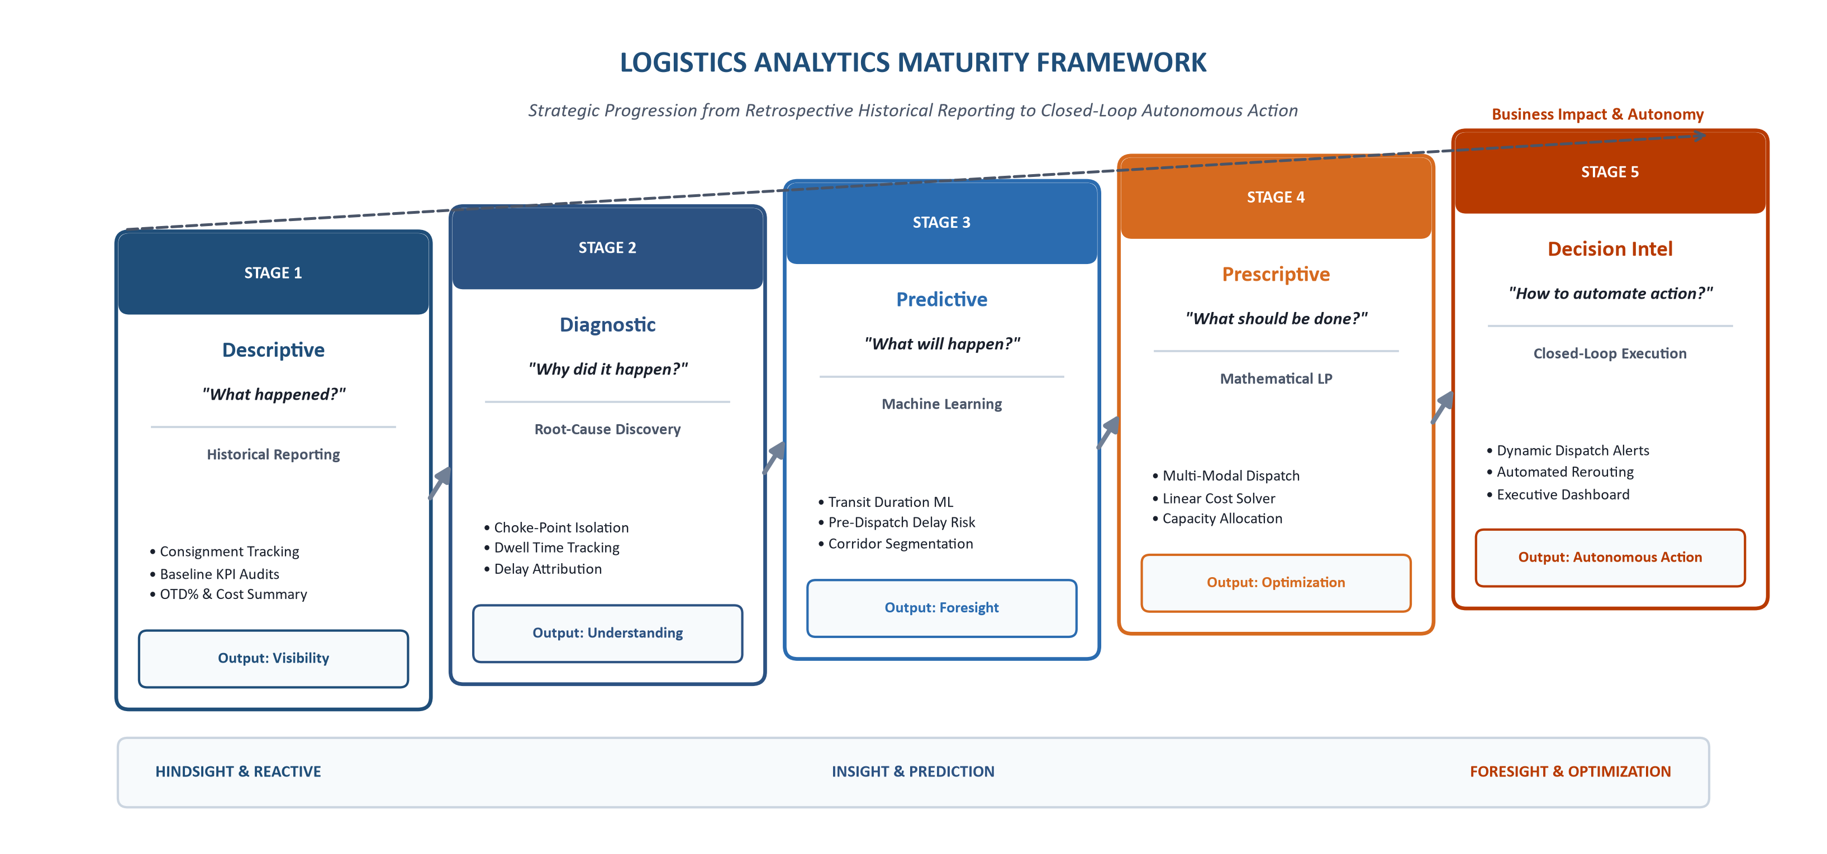
Figure 3: Analytics Maturity Framework: Descriptive to Decision Intelligence
Maturity Stages: Each stage serves a distinct operational purpose:
• 1. Descriptive Analytics: Establishes historical baseline visibility. Answers 'What happened?' across the network by computing OTD%, average transit velocity, modal cost splits, and regional volume throughput.
• 2. Diagnostic Analytics: Isolates operational bottlenecks and root causes. Answers 'Why did delays and cost spikes happen?' through multivariate correlation analysis, cross-dock dwell tracking, and carrier delay attribution.
• 3. Predictive Analytics: Generates forward-looking estimates. Answers 'What is likely to happen?' by deploying supervised machine learning to forecast continuous transit durations (Regression) and classify pre-dispatch delay risks (Classification).
• 4. Prescriptive Analytics: Determines optimal operational choices. Answers 'What should we do?' by formulating Linear Programming models that allocate shipments across modes to minimize total network costs subject to capacity and SLA limits.
• 5. Decision Intelligence: Connects analytical findings with operational decision-makers. Combines predictive and prescriptive model outputs into automated dispatcher exception alerts, dynamic routing rules, and executive scorecards.

14. Regression Modeling Strategy (Transit Duration Forecasting)
The primary predictive objective is forecasting continuous shipment transit duration in hours (Delivery_Time_Hours). Accurate duration predictions allow dispatchers to dynamically generate realistic customer arrival appointments, schedule cross-dock staging labor, and identify potential SLA violations hours before line-haul departure.
Delivery elapsed time is governed by non-linear interactions among distance, gross payload weight, transportation mode physics, and regional terrain. While Ordinary Least Squares (OLS) regression provides a useful linear baseline for statistical hypothesis testing, it cannot capture non-linear relationships such as the quadratic fuel-drag curve of heavy commercial vehicles or the step-function delay penalties associated with urban toll rings. We design a model evaluation framework comparing four candidate algorithms:
Table 8: Supervised Regression Modeling Strategy & Algorithm Blueprint
Algorithm Candidate | Mathematical Formulation | Logistics Analytics Advantages | Limitations & Operational Risks | Planned Benchmark Role
Ordinary Least Squares (OLS) | Y = β₀ + ∑ βᵢXᵢ + ε  Minimizes residual sum of squares | Direct interpretability; explicit coefficients reveal marginal hours per KM and per ton. | Fails on non-linear terrain features; sensitive to collinearity between distance and cost. | Baseline diagnostic benchmark model.
Ridge & Lasso Regularization | L2 (Ridge): ∑(Y − ŷ)² + λ∑βᵢ²  L1 (Lasso): ∑(Y − ŷ)² + λ∑|βᵢ| | Penalizes collinear geographical hub features; Lasso performs automated feature selection. | Still fundamentally constrained by linear additive assumptions. | Intermediate linear regularization benchmark.
Random Forest Regressor | Ensemble of B decorrelated bootstrap decision trees: (1/B) ∑ Tᵧ(X) | Captures non-linear feature interactions; resilient to skewed freight data and outliers. | Higher memory footprint; slower real-time inference on massive batch scoring pipelines. | Primary robust production candidate model.
Gradient Boosted Trees (LightGBM) | Sequential additive tree boosting optimizing pseudo-residuals via leaf-wise growth | State-of-the-art predictive accuracy; handles high-cardinality categorical hub codes natively. | Requires careful hyperparameter regularization to prevent overfitting small-sample corridors. | Champion algorithm candidate for production ETA.

15. Classification Strategy (Pre-Dispatch Delay Risk)
In addition to continuous duration forecasting, operational dispatchers require a discrete binary classification tool that flags whether a scheduled consignment is at high risk of breaching its promised SLA (Delay_Flag = 1). Pre-dispatch risk classification allows dispatchers to intervene proactively—either by upgrading the shipment to a faster mode, assigning team drivers, or pre-alerting destination receivers.
Candidate classification models include Logistic Regression (calibrated baseline), Random Forest Classifier, and XGBoost Classifier. Models will be trained on pre-dispatch features (excluding any post-departure tracking data). Because false negatives (failing to detect a delay that results in client chargebacks) are more operationally costly than false positives (a false alarm prompting dispatcher review), the classification decision threshold will be evaluated using Precision-Recall Curves to prioritize Recall (≥ 85%) while maintaining Precision (≥ 80%).
16. Clustering and Segmentation Strategy (Corridor Profiling)
Unsupervised machine learning enables the discovery of operational patterns across thousands of origin-destination lanes without requiring pre-labeled training targets. We deploy K-Means and Agglomerative Hierarchical Clustering across normalized route features (Average Distance, Average Transit Hours, Delay Rate, Cost per KM, and Payload Density):
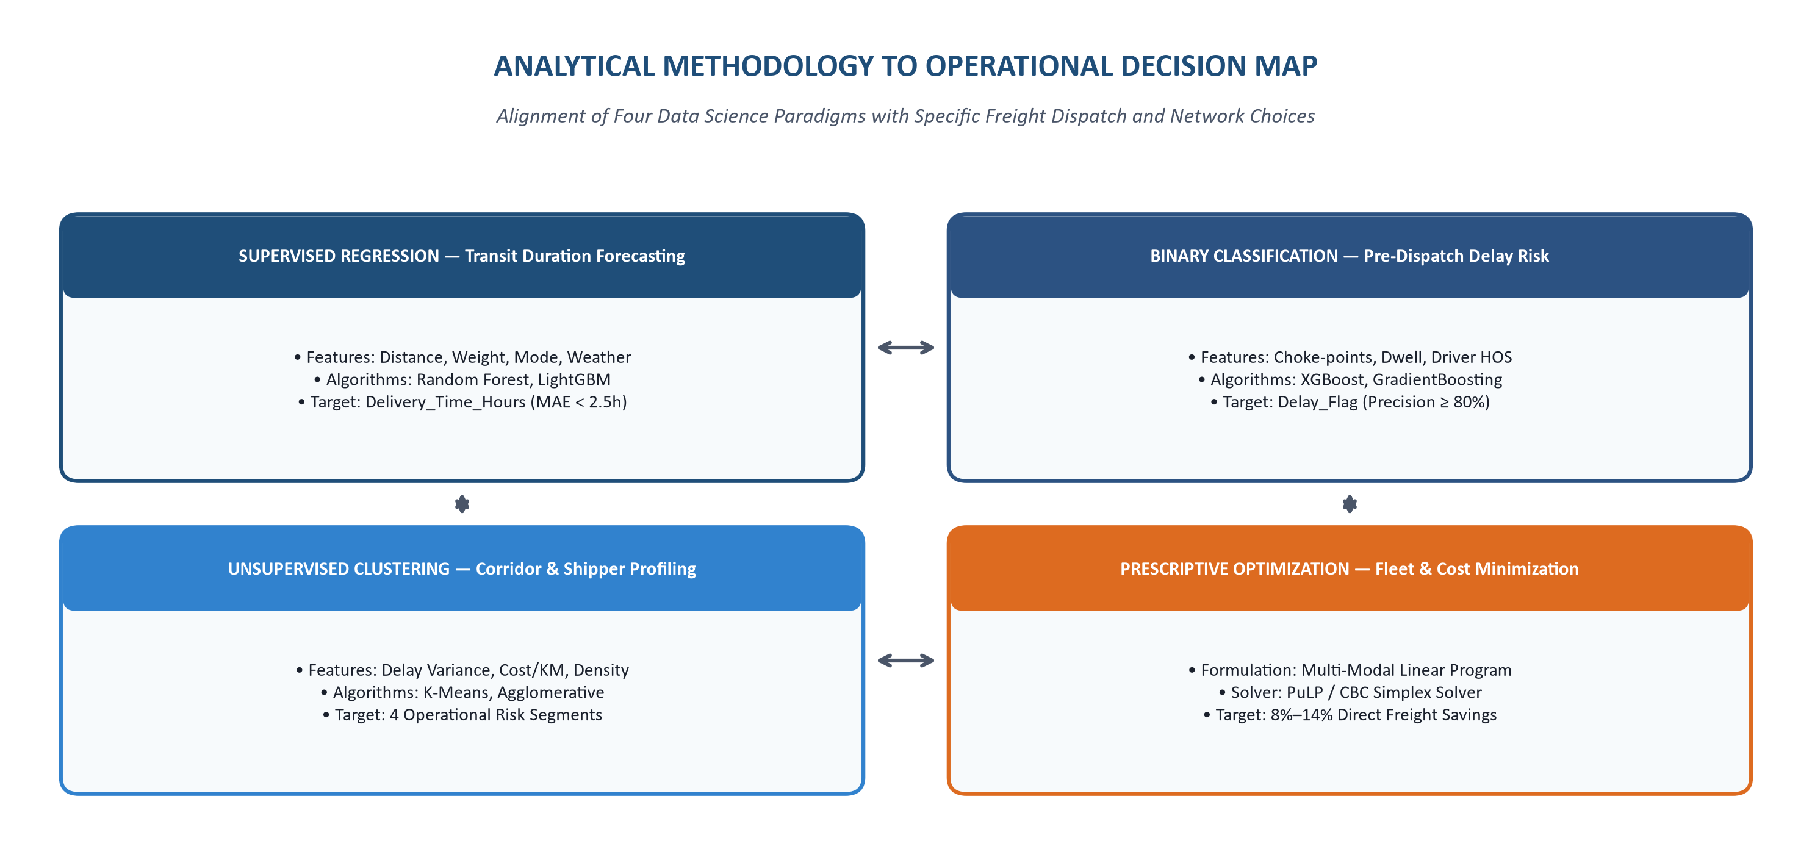
Figure 4: Analytical Methodology to Operational Decision Map
Target Operational Segments: Clustering segments the multi-regional network into four operational archetypes:
• Cluster 0 (Core Stable Corridors): High-volume, highly reliable, low-cost line-haul routes (e.g., Midwest interstate links) suitable for automated, scheduled dispatching.
• Cluster 1 (High-Risk Volatile Corridors): Long-haul routes characterized by severe weather disruption, mountain passes, and volatile transit times requiring dynamic buffer scheduling.
• Cluster 2 (High-Cost Friction Corridors): Short-to-medium distance lanes with disproportionately high toll, drayage, and urban congestion costs requiring route re-negotiation.
• Cluster 3 (Low-Density Spoke Lanes): Secondary spoke routes with highly irregular demand, low volumetric load factors, and frequent LTL partial loadings requiring consolidation.
17. Optimization and Prescriptive Analytics Strategy
While predictive machine learning models forecast transit durations and delay probabilities, prescriptive optimization determines the mathematically optimal allocation of freight consignments across available transportation modes and routes. The core operational challenge is minimizing total network transportation expenditures while ensuring that all destination hub demands are satisfied, vehicle fleet capacity bounds are respected, and customer SLA commitments are upheld.
Formal Mathematical Linear Programming Model Formulation
The enterprise freight allocation problem is formulated as a multi-commodity, multi-modal Linear Program (LP) as follows:
Mathematical Formulation: Multi-Modal Freight Cost Minimization
Objective Function:
Minimize Z = ∑ᵢ ∑ⱼ ∑ₘ (Cᵢⱼₘ × Xᵢⱼₘ)
Where:
• Xᵢⱼₘ = Number of consignment freight units shipped from Origin Hub i to Destination Hub j via Mode m
• Cᵢⱼₘ = Direct unit transportation expenditure ($) incurred between hub i and j via mode m
Subject to the following operational constraints:
1. Destination Demand Satisfaction: ∑ᵢ ∑ₘ Xᵢⱼₘ ≥ Dⱼ, ∀ destination hubs j
2. Origin Terminal Supply Limits: ∑ⱼ ∑ₘ Xᵢⱼₘ ≤ Sᵢ, ∀ origin terminals i
3. Vehicle Fleet Capacity Bounds: ∑ᵢ ∑ⱼ (Wₖ × Xᵢⱼₘ) ≤ CAPₘ, ∀ transportation modes m
4. Contractual SLA Transit Limit: Tᵢⱼₘ ≤ SLAⱼ, ∀ scheduled consignments
5. Integrality and Non-Negativity: Xᵢⱼₘ ∈ ℤ⁺ (Integer consignment units)

By directly injecting the machine-learning predicted transit duration (T_ijm) into Constraint 4, the optimization solver creates an integrated predictive-prescriptive feedback loop. If the Random Forest regressor predicts that an FTL ground shipment on a specific lane will exceed the customer's 48-hour SLA due to severe winter weather, the solver automatically evaluates alternative routes or modes (e.g., Intermodal Rail or Express Air), preserving SLA compliance at the lowest incremental cost.
18. End-to-End Analytical Lifecycle
To ensure structured, reproducible execution across the entire analytics initiative, we define a 10-stage end-to-end analytical lifecycle:
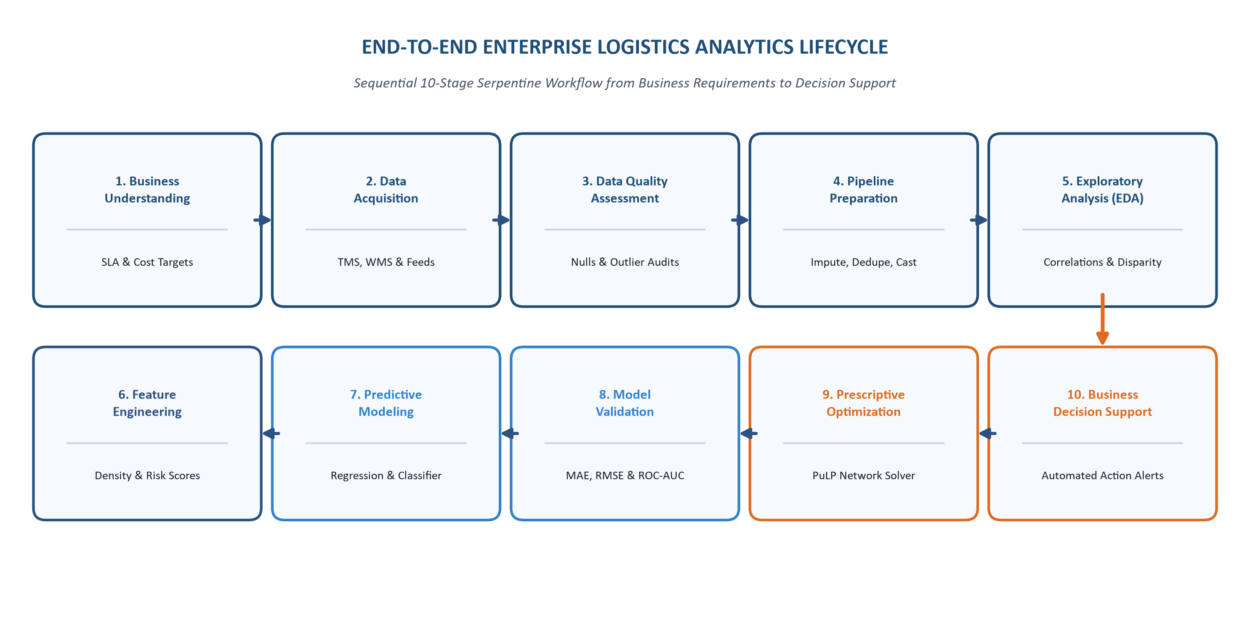
Figure 5: End-to-End Enterprise Logistics Analytics Lifecycle
Table 9: End-to-End Analytics Lifecycle Phase Specifications
Lifecycle Stage | Phase Purpose & Focus | Input Data & Artifacts | Output Deliverables | Core Techniques & Tools
1. Business Understanding | Elicit operational pain points; define SLA targets and cost benchmarks. | Executive interviews, operational problem audits | Formulated business case, KPI hierarchy | Stakeholder requirements elicitation, KPI mapping.
2. Data Acquisition | Extract shipping records from operational databases and external APIs. | TMS manifests, WMS logs, GPS feeds, NOAA APIs | Consolidated raw staging datasets | SQL batch extraction, REST APIs, Kafka streaming.
3. Data Quality Audit | Quantify missing values, invalid types, corrupted timestamps. | Raw ingested shipping tables | Data quality audit matrix, profiling reports | Pandas nullity scanning, schema assertions.
4. Data Preparation | Execute programmatic cleaning, imputation, deduplication, scaling. | Raw audited staging tables | Cleaned master Parquet dataset | Median imputation, MD5 deduplication, RobustScaler.
5. Exploratory Analysis | Profile univariate distributions, bivariate trends, and correlations. | Cleaned master dataset | Interactive Plotly charts, modal cost benchmarks | Pandas groupby, Plotly Express histograms/heatmaps.
6. Feature Engineering | Construct domain features: density ratios, risk scores, dwell. | Cleaned transactional features | High-dimensional feature matrix | Haversine formula, temporal cyclical encoding.
7. Predictive Modeling | Train regression and classification models for transit time and delay. | Engineered feature matrix | Trained ML pipelines (RF, LightGBM, XGBoost) | Scikit-Learn ColumnTransformer, cross-validation.
8. Model Validation | Evaluate predictive accuracy on held-out chronological test sets. | Test feature splits, ground-truth timestamps | Validation scorecards (MAE, RMSE, ROC-AUC) | TimeSeriesSplit, residual analysis, ROC curves.
9. Prescriptive Optimization | Formulate and solve multi-modal freight cost minimization models. | Predicted transit times, fleet capacities, tariffs | Mathematically optimal dispatch schedules | PuLP, CBC Simplex linear solver, sensitivity analysis.
10. Decision Support | Deploy interactive executive dashboards and automated alerts. | Model predictions, optimization schedules | Interactive Plotly dashboards, automated alerts | Plotly Dash / Streamlit, Python automated reporting.

19. Proposed Enterprise Analytics Architecture
The proposed system is architected as a modular, decoupled 4-tier enterprise software and data engineering stack, ensuring horizontal scalability, data governance, and clean separation of concerns:
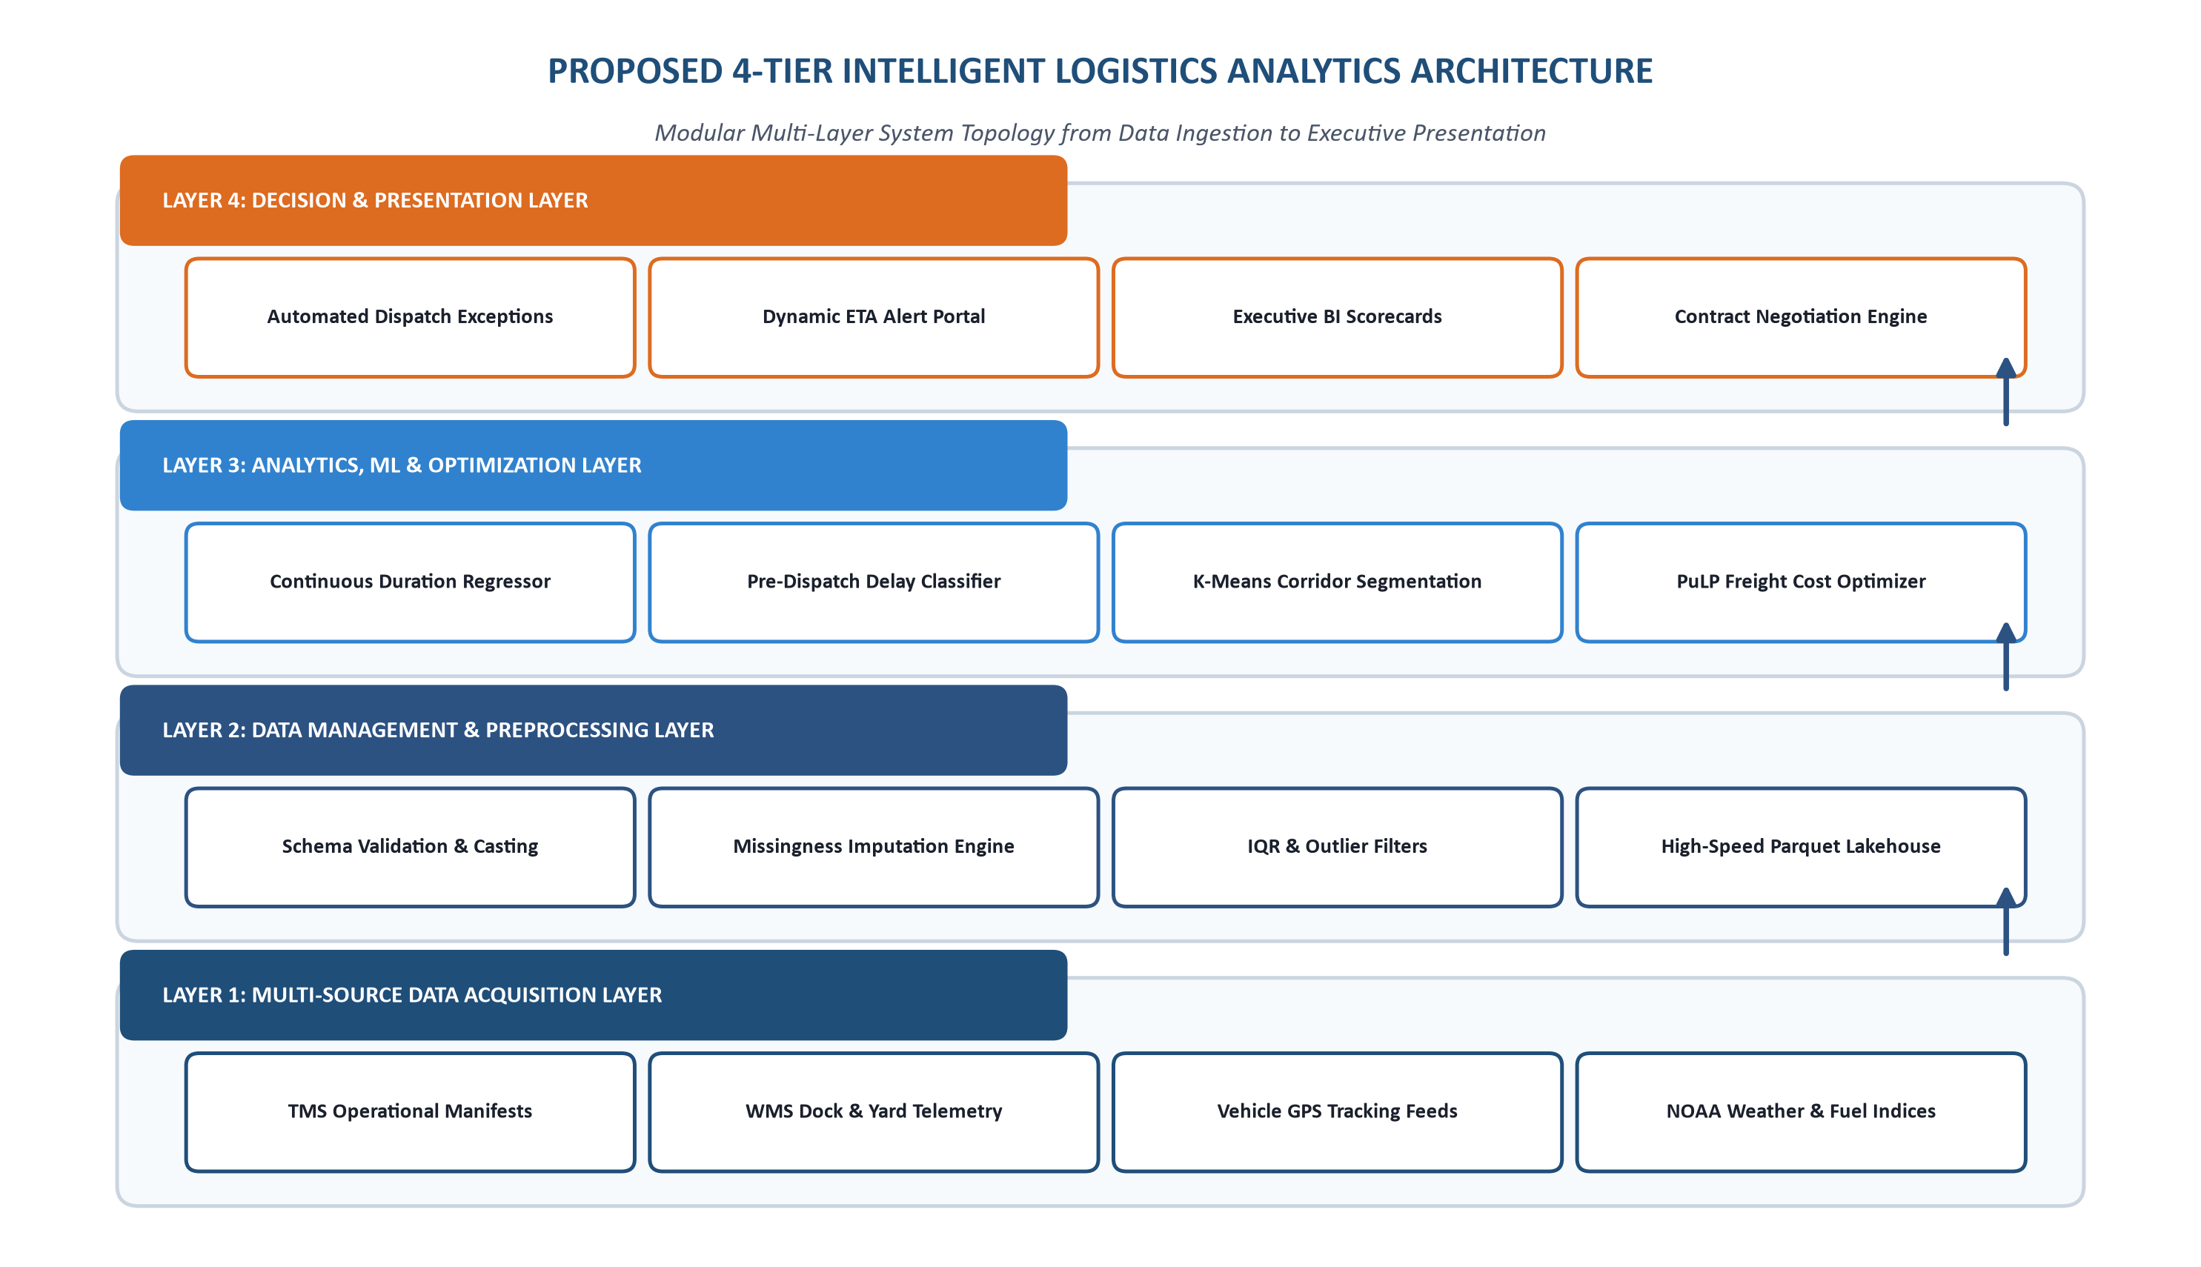
Figure 6: Proposed 4-Tier Intelligent Logistics System Architecture
Architectural Layers: Detailed functional breakdown of each architectural layer:
• Layer 1 (Data Acquisition Layer): Consolidates transactional manifests from enterprise Transportation Management Systems (TMS), terminal gate scanning feeds from Warehouse Management Systems (WMS), continuous telematics breadcrumbs from vehicle GPS units, and external environmental feeds from NOAA weather and fuel price index APIs.
• Layer 2 (Data Management Layer): Enforces automated schema validation, missingness imputation engines, Interquartile Range (IQR) outlier filters, and standardized ISO-8601 temporal parsing, persisting clean data structures into high-performance columnar Parquet storage.
• Layer 3 (Analytics & Machine Learning Layer): Houses the core data science computational engines: supervised regression models for continuous duration forecasting, binary classification pipelines for pre-dispatch delay risk detection, unsupervised K-Means corridor segmentation, and PuLP linear programming optimization solvers.
• Layer 4 (Decision & Presentation Layer): Delivers analytical insights directly to operational decision-makers through automated dispatcher exception tickets, dynamic customer ETA alert portals, interactive executive KPI scorecards built in Plotly Dash, and carrier contract negotiation scorecards.
20. Data Collection and Integration Strategy
Enterprise logistics networks generate heterogeneous data streams ranging from structured transactional manifests to semi-structured GPS telematics strings. Our data collection and integration strategy establishes standardized protocols to ingest and harmonize these disparate sources:
• Structured Operational Records: Daily batch extracts from enterprise PostgreSQL / Oracle TMS databases capturing consignment codes, scheduled departure windows, booked modes, billing rates, and line-haul carrier contracts.
• Semi-Structured Telematics Streams: Kafka streaming consumers ingesting terminal gate barcode scans (arrival and departure events) and vehicle GPS waypoint pings (latitude, longitude, instantaneous speed, odometer readings).
• Exogenous Environmental Feeds: Daily automated REST API queries fetching historical weather storm warnings (NOAA) and wholesale diesel fuel prices (U.S. EIA).
• Integration Standardization Rules: All timestamps are converted to UTC ISO-8601 strings; geographic hub codes are validated against a master terminal geospatial dictionary; and freight billing amounts are normalized to USD ($) using daily currency conversion tables.
21. Data Preparation Strategy & Hygiene Pipeline
Data preparation transforms raw operational records into a standardized, model-ready feature matrix. The data hygiene pipeline executes eleven sequential operations:
Data Hygiene Pipeline: Raw Staging Ingestion → Schema Assertion & Validation → Hash-Based Deduplication (MD5) → Missing Value Imputation (Conditional Median) → Datetime Standardization (ISO-8601) → Outlier Detection & Winsorization (IQR Fencing) → Categorical Encoding (One-Hot / Target Encoding) → Feature Scaling (RobustScaler) → Feature Engineering (Density & Circuity Ratios) → Integrity Verification Assertions → Master Parquet Storage.
Outlier detection is handled through dual statistical protocols: Interquartile Range (IQR) fencing flags univariate anomalies in freight costs and shipment weights, while physical range checks (asserting that transit speeds do not exceed 110 km/h or fall below 0) eliminate recording errors. Continuous numerical features are scaled using Scikit-Learn's RobustScaler, which scales data using the interquartile range, preventing extreme freight outliers from distorting model coefficients.

22. Exploratory Data Analysis (EDA) Strategy
Exploratory Data Analysis (EDA) is the essential diagnostic phase that transforms raw observations into actionable operational hypotheses. Conducting thorough EDA prior to predictive modeling prevents the deployment of biased algorithms and exposes hidden structural patterns across transportation corridors. For all programmatic visualizations, Plotly Express and Plotly Graph Objects serve as the primary interactive graphics framework:
Table 10: Exploratory Data Analysis (EDA) Planning Matrix (Plotly Framework)
Analytical Focus Area | Key Variables Analyzed | Analytical Technique | Target Plotly Visualization | Expected Operational Insight
Univariate Distributions | Delivery_Time_Hours, Transportation_Cost, Distance_KM | Summary statistics, skewness, kurtosis, kernel density | Interactive Plotly Histograms (px.histogram) with Box Overlays | Identify distribution skewness, bimodality, and heavy-tailed transit durations.
Bivariate Relationships | Distance vs. Delivery Time, Weight vs. Cost | Pearson & Spearman rank correlation coefficients | Interactive Scatter Plots (px.scatter) with OLS Trendlines | Quantify linear and non-linear dependencies; assess if weight or distance dominates delay.
Multi-Modal Benchmarking | Transportation_Mode vs. Cost/KM and Transit Velocity | ANOVA F-tests, interquartile distribution comparisons | Interactive Box Plots (px.box) and Violin Plots (go.Violin) | Detect modal inefficiencies where express air freight fails to provide transit velocity advantages.
Regional Disparities | Region & Hubs vs. On-Time Delivery Rate (OTD%) | Cross-tabulations, regional performance indexing | Choropleth Maps (px.choropleth) & Hub Heatmaps (px.imshow) | Isolate geographic choke-points; expose regional terminals with structural delays.
Temporal Seasonality | Dispatch_Date (Hour, Day-of-Week, Month) vs. Delays | Time-series decomposition, rolling moving averages | Interactive Line Charts (px.line) & 2D Calendar Heatmaps | Expose weekend dispatch volume surges and Friday cross-dock staging bay gridlock.
Delay Root-Cause Attribution | Delay categories: Weather, Mechanical, Traffic, Facility | Pareto frequency analysis (80/20 rule) | Interactive Bar & Cumulative Line Charts (go.Bar + go.Scatter) | Focus operational interventions on the vital few causes driving 80% of SLA breaches.

23. Feature Engineering Strategy
Raw transactional shipping records lack the domain-specific context required for high-accuracy machine learning. We construct six engineered features that directly capture operational physics, capacity density, and route friction:
• 1. Delivery_Duration_Hours: Computed as the true elapsed duration: (Delivery_Date − Shipment_Date) in decimal hours. Establishes the continuous target variable for regression.
• 2. Cost_per_KM: Computed as Transportation_Cost / Distance_KM. Normalizes expenditures against haul distance, exposing regional route cost inflation.
• 3. Weight_to_Distance_Ratio: Computed as Shipment_Weight_KG / Distance_KM. Measures freight payload intensity; high ratios indicate heavy line-haul transport with elevated fuel consumption.
• 4. Freight_Density_KG_M3: Computed as Shipment_Weight_KG / Shipment_Volume_M3 (expressed in kg/m³). Differentiates between dense freight that causes tractor weigh-out versus bulky freight that causes cube-out.
• 5. Route_Risk_Score: Composite score (0.00 to 1.00) calculated from historical mountain elevation change, winter weather severity indices, and urban congestion intersection density.
• 6. Historical_Lane_Delay_Rate: Rolling 30-day historical delay percentage for the specific origin-destination corridor, capturing chronic structural bottlenecks.
24. Predictive Modeling Blueprint & Validation Framework
The predictive modeling lifecycle is structured across ten methodical steps: Problem Formulation → Target & Feature Definition → Chronological Train/Validation/Test Split → Preprocessing Pipeline Definition → Baseline Model Training → Candidate Model Benchmarking → Cross-Validation → Hyperparameter Optimization → Held-Out Test Evaluation → Operational Business Interpretation.
Chronological Validation Protocol: To prevent future data leakage, random train-test splitting is strictly avoided. We mandate a chronological TimeSeriesSplit: the earliest 80% of records represent the Training Set, the next 10% represent the Validation Set for tuning, and the final 10% represent the strictly held-out Test Set.
Evaluation Metrics: Models will be evaluated against a comprehensive suite of statistical metrics:
• Regression Metrics (Objective A): Mean Absolute Error (target MAE < 2.50 hours), Root Mean Squared Error (target RMSE < 4.20 hours), and Coefficient of Determination (target R² ≥ 0.85).
• Classification Metrics (Objective B): Precision (target ≥ 80.0%), Recall (target ≥ 85.0%), F1-Score (target ≥ 0.82), and Receiver Operating Characteristic Area Under Curve (target ROC-AUC ≥ 0.88).
25. Python Technology and Implementation Environment
The entire data analytics, machine learning, and optimization architecture is implemented in Python 3.10+, utilizing established scientific computing libraries. Plotly serves as the primary visualization framework for interactive dashboards and visual analytics:
Table 11: Python Analytics & Machine Learning Technology Stack
Technology / Tool | Target Version | Primary Functional Purpose | Operational Implementation Role
Python Core | 3.10.x / 3.11.x | Runtime execution environment | Provides memory management, multi-threading, and object-oriented pipeline architecture.
Pandas | 2.1.x+ | High-performance tabular data wrangling | Dataframe ingestion, cleaning, datetime parsing, and vectorized KPI aggregation.
NumPy | 1.24.x+ | Vectorized linear algebra & matrix operations | Underpins numerical transformations, Haversine formula calculation, and array math.
Scikit-Learn | 1.3.x+ | Machine learning modeling and preprocessing | ColumnTransformer pipelines, regression models, K-Means clustering, and evaluation.
SciPy | 1.11.x+ | Scientific computing & statistical distributions | Outlier statistical tests (Z-score), probability distributions, and curve fitting.
PuLP | 2.7.x+ | Linear Programming (LP) and MILP modeling | Formulates and solves cost-minimization dispatch optimization models.
Plotly Express & Graph Objects | 5.18.x+ | Interactive visualization & dashboard framework | Renders interactive distributions, modal box plots, correlation heatmaps, and KPI indicators.
JupyterLab / VSCode | 3.6.x+ | Interactive development & prototyping IDE | Provides interactive notebook environment for rapid prototyping and EDA verification.

26. Python Implementation Blueprints
To demonstrate technical architecture, the following modular Python scripts illustrate the proposed data engineering, exploratory analysis, predictive modeling, and optimization workflows. These blueprints represent Week 1 architectural designs and implementation patterns rather than completed post-execution results.
Module A: Automated Data Ingestion & Schema Validation Blueprint
This module ingests raw multi-modal shipping records, asserts column presence, enforces strict data types, and validates primary key uniqueness:
Listing: Module A: Data Ingestion and Schema Validation Pipeline
import pandas as pd
import numpy as np
import logging
from typing import Dict, Any
logging.basicConfig(level=logging.INFO, format="%(asctime)s - %(levelname)s - %(message)s")
def ingest_and_validate_manifests(filepath: str) -> pd.DataFrame:
"""
Ingests raw logistics shipping manifests and enforces strict schema validation.
Asserts mandatory columns, casts proper data types, and purges duplicate IDs.
"""
expected_dtypes = {
"Shipment_ID": "object",
"Origin_Hub": "category",
"Destination_Hub": "category",
"Region": "category",
"Transportation_Mode": "category",
"Distance_KM": "float64",
"Shipment_Weight_KG": "float64",
"Shipment_Volume_M3": "float64",
"Transportation_Cost": "float64",
"Promised_Time_Hours": "float64"
}
date_columns = ["Order_Date", "Shipment_Date", "Delivery_Date"]
logging.info(f"Loading logistics data from: {filepath}")
df = pd.read_csv(filepath, parse_dates=date_columns)
# Assert column presence
missing = [c for c in expected_dtypes.keys() if c not in df.columns]
if missing:
raise ValueError(f"Schema Assertion Failed! Missing mandatory columns: {missing}")
for col, dtype in expected_dtypes.items():
df[col] = df[col].astype(dtype)
# Assert primary key uniqueness
if not df["Shipment_ID"].is_unique:
dups = df["Shipment_ID"].duplicated().sum()
logging.warning(f"Detected {dups} duplicate Shipment_IDs! Purging duplicates...")
df = df.drop_duplicates(subset=["Shipment_ID"], keep="first")
logging.info(f"Validation successful. Cleaned manifest shape: {df.shape[0]} rows, {df.shape[1]} columns.")
return df

Module B: Data Quality Auditing & Missingness Profiling Blueprint
This module audits column nullity percentages and flags features requiring conditional imputation:
Listing: Module B: Data Quality and Missingness Profiler
def audit_data_quality(df: pd.DataFrame) -> pd.DataFrame:
"""
Scans dataset for null values, calculates sparsity percentages,
and flags variables requiring conditional imputation.
"""
null_counts = df.isnull().sum()
null_pct = (null_counts / len(df)) * 100.0
audit_report = pd.DataFrame({
"Feature_Name": df.columns,
"Missing_Records": null_counts.values,
"Missing_Percentage": null_pct.values.round(2)
})
audit_report["Action_Required"] = audit_report["Missing_Percentage"] > 0.0
audit_report["Imputation_Strategy"] = np.where(
audit_report["Missing_Percentage"] > 0, "Conditional Median by Mode", "None"
)
print("
--- DATA QUALITY & NULLITY PROFILE ---")
print(audit_report[audit_report["Action_Required"]].to_string(index=False))
return audit_report

Module C: Vectorized Logistics KPI Performance Engine Blueprint
This module executes vectorized mathematical computations for core logistics performance metrics:
Listing: Module C: Vectorized KPI Calculation Engine
def compute_logistics_kpis(df: pd.DataFrame) -> Dict[str, float]:
"""
Computes primary operational KPIs using vectorized Pandas methods.
Calculates true elapsed transit time, delay flags, OTD%, and Cost per KM.
"""
df = df.copy()
df["Delivery_Time_Hours"] = (df["Delivery_Date"] - df["Shipment_Date"]).dt.total_seconds() / 3600.0
df["Delay_Flag"] = np.where(df["Delivery_Time_Hours"] > df["Promised_Time_Hours"], 1, 0)
total_shipments = len(df)
ontime_shipments = (df["Delay_Flag"] == 0).sum()
otd_rate = (ontime_shipments / total_shipments) * 100.0
delay_rate = 100.0 - otd_rate
avg_delivery_time = df["Delivery_Time_Hours"].mean()
total_cost = df["Transportation_Cost"].sum()
total_km = df["Distance_KM"].sum()
kpis = {
"Total_Shipments": float(total_shipments),
"On_Time_Delivery_Rate_Pct": round(otd_rate, 2),
"Delivery_Delay_Rate_Pct": round(delay_rate, 2),
"Average_Delivery_Time_Hours": round(avg_delivery_time, 2),
"Cost_Per_Shipment_USD": round(total_cost / total_shipments, 2),
"Cost_Per_KM_USD": round(total_cost / total_km, 3)
}
print("
--- ENTERPRISE LOGISTICS KPI SCORECARD ---")
for k, v in kpis.items():
print(f" • {k}: {v}")
return kpis

Module D: Interactive Plotly Visualization & Exploratory Suite Blueprint
This module implements the primary exploratory visualization framework using Plotly Express and Graph Objects, rendering interactive distributions, modal box plots, and correlation heatmaps:
Listing: Module D: Interactive Plotly Visualization Suite
import plotly.express as px
import plotly.graph_objects as go
import pandas as pd
def generate_interactive_eda_visualizations(df: pd.DataFrame) -> None:
"""
Constructs interactive logistics visualizations using Plotly Express and Graph Objects.
Generates distribution plots, modal cost comparisons, and route correlation heatmaps.
"""
# 1. Interactive Transit Duration Distribution across Transport Modes
fig_hist = px.histogram(
df, x="Delivery_Time_Hours", color="Transportation_Mode",
barmode="overlay", nbins=50,
title="Interactive Transit Duration Distribution by Transport Mode",
labels={"Delivery_Time_Hours": "Elapsed Transit Duration (Hours)"},
color_discrete_sequence=["#1F4E79", "#1F497D", "#E46C0A", "#ED7D31"]
)
fig_hist.update_layout(template="plotly_white", xaxis_title="Elapsed Hours", yaxis_title="Shipment Count")
# 2. Interactive Modal Cost Variance Box Plot across Regions
fig_box = px.box(
df, x="Transportation_Mode", y="Transportation_Cost", color="Region",
title="Line-Haul Transportation Cost Variance across Operational Regions",
labels={"Transportation_Cost": "Freight Expenditure (USD)"}
)
fig_box.update_layout(template="plotly_white")
# 3. Interactive Numerical Feature Correlation Heatmap
num_cols = ["Distance_KM", "Shipment_Weight_KG", "Shipment_Volume_M3", "Transportation_Cost", "Delivery_Time_Hours"]
corr = df[num_cols].corr()
fig_corr = px.imshow(
corr, text_auto=".2f", color_continuous_scale="Blues",
title="Interactive Feature Correlation Matrix (Plotly Imshow)"
)
fig_corr.update_layout(template="plotly_white")
print("Plotly interactive visualization suite initialized successfully.")

Module E: Domain Feature Engineering Pipeline Blueprint
This module derives domain features including payload density and cost-per-km metrics:
Listing: Module E: Feature Engineering Pipeline
def engineer_logistics_features(df: pd.DataFrame) -> pd.DataFrame:
"""
Constructs domain-specific logistics features:
Freight density (kg/m3), cost per km, and weight-to-distance ratio.
"""
df = df.copy()
df["Cost_per_KM"] = df["Transportation_Cost"] / df["Distance_KM"].replace(0, np.nan)
df["Freight_Density_KG_M3"] = df["Shipment_Weight_KG"] / df["Shipment_Volume_M3"].replace(0, np.nan)
df["Weight_to_Distance_Ratio"] = df["Shipment_Weight_KG"] / df["Distance_KM"].replace(0, np.nan)
logging.info(f"Engineered 3 domain features. Final column count: {df.shape[1]}")
return df

Module F: Supervised Regression Pipeline Blueprint (Scikit-Learn)
This module builds an end-to-end ColumnTransformer and Random Forest Regressor pipeline to forecast continuous transit duration:
Listing: Module F: Supervised Regression Pipeline Blueprint
from sklearn.model_selection import train_test_split
from sklearn.preprocessing import OneHotEncoder, RobustScaler
from sklearn.compose import ColumnTransformer
from sklearn.pipeline import Pipeline
from sklearn.ensemble import RandomForestRegressor
from sklearn.metrics import mean_absolute_error, mean_squared_error, r2_score
def build_regression_pipeline(df: pd.DataFrame) -> Pipeline:
"""
Builds and evaluates a Random Forest Regression pipeline for transit duration forecasting.
Enforces chronological train-test split to prevent temporal data leakage.
"""
features = ["Distance_KM", "Shipment_Weight_KG", "Shipment_Volume_M3",
"Transportation_Mode", "Origin_Hub", "Destination_Hub", "Region"]
target = "Delivery_Time_Hours"
clean_df = df.dropna(subset=[target]).copy()
X = clean_df[features]
y = clean_df[target]
# Chronological 80/20 train-test split (shuffle=False)
X_train, X_test, y_train, y_test = train_test_split(X, y, test_size=0.20, shuffle=False)
preprocessor = ColumnTransformer(
transformers=[
("num", RobustScaler(), ["Distance_KM", "Shipment_Weight_KG", "Shipment_Volume_M3"]),
("cat", OneHotEncoder(handle_unknown="ignore", sparse_output=False),
["Transportation_Mode", "Origin_Hub", "Destination_Hub", "Region"])
]
)
model = Pipeline(steps=[
("preprocessor", preprocessor),
("regressor", RandomForestRegressor(n_estimators=100, max_depth=15, random_state=42, n_jobs=-1))
])
print("Fitting Random Forest Transit Duration Regressor...")
model.fit(X_train, y_train)
preds = model.predict(X_test)
mae = mean_absolute_error(y_test, preds)
rmse = np.sqrt(mean_squared_error(y_test, preds))
r2 = r2_score(y_test, preds)
print(f"
Held-Out Test Evaluation: MAE={mae:.2f}h, RMSE={rmse:.2f}h, R²={r2:.3f}")
return model

Module G: Unsupervised Route Clustering Blueprint (K-Means)
This module normalizes lane-level performance features and applies K-Means to identify four operational corridor risk clusters:
Listing: Module G: Unsupervised Route Clustering Blueprint
from sklearn.cluster import KMeans
from sklearn.preprocessing import StandardScaler
from sklearn.metrics import silhouette_score
def cluster_corridor_risk_profiles(df: pd.DataFrame, k: int = 4) -> pd.DataFrame:
"""
Clusters delivery corridors into 4 operational risk profiles using K-Means.
Computes silhouette scores to evaluate cluster separation.
"""
lane_stats = df.groupby(["Origin_Hub", "Destination_Hub"]).agg(
Avg_Distance=("Distance_KM", "mean"),
Avg_Transit_Hours=("Delivery_Time_Hours", "mean"),
Delay_Rate=("Delay_Flag", "mean"),
Avg_Cost_KM=("Transportation_Cost", lambda c: c.sum() / df.loc[c.index, "Distance_KM"].sum())
).dropna().reset_index()
features = ["Avg_Distance", "Avg_Transit_Hours", "Delay_Rate", "Avg_Cost_KM"]
scaled = StandardScaler().fit_transform(lane_stats[features])
kmeans = KMeans(n_clusters=k, random_state=42, n_init=10)
lane_stats["Cluster_Archetype"] = kmeans.fit_predict(scaled)
sil = silhouette_score(scaled, lane_stats["Cluster_Archetype"])
print(f"
K-Means Route Clustering Complete. Silhouette Score: {sil:.3f}")
print(lane_stats.groupby("Cluster_Archetype")[features].mean().round(2))
return lane_stats

Module H: Prescriptive Linear Programming Solver Blueprint (PuLP)
This module implements a multi-modal freight cost minimization model in PuLP, solving for the optimal consignment allocation subject to capacity and SLA bounds:
Listing: Module H: Prescriptive Linear Programming Optimization Blueprint
import pulp
def solve_multi_modal_dispatch_lp(origins, destinations, modes, costs, demand, supply, capacities):
"""
Formulates and solves a multi-modal freight cost minimization model using PuLP.
Minimizes total transportation expenditures subject to demand, capacity, and SLA bounds.
"""
prob = pulp.LpProblem("Logistics_Freight_Cost_Minimization", pulp.LpMinimize)
# Decision Variables: units shipped from origin i to destination j via mode m
routes = [(i, j, m) for i in origins for j in destinations for m in modes]
x = pulp.LpVariable.dicts("Shipment_Units", routes, lowBound=0, cat=pulp.LpInteger)
# Objective Function: Minimize Total Network Transportation Cost
prob += pulp.lpSum([x[i, j, m] * costs[i][j][m] for (i, j, m) in routes]), "Total_Cost"
# Constraint 1: Satisfy Destination Demand
for j in destinations:
prob += pulp.lpSum([x[i, j, m] for i in origins for m in modes]) >= demand[j], f"Demand_{j}"
# Constraint 2: Origin Terminal Supply Limits
for i in origins:
prob += pulp.lpSum([x[i, j, m] for j in destinations for m in modes]) <= supply[i], f"Supply_{i}"
# Constraint 3: Modal Vehicle Fleet Capacities
for m in modes:
prob += pulp.lpSum([x[i, j, m] for i in origins for j in destinations]) <= capacities[m], f"Capacity_{m}"
# Solve with CBC Solver
prob.solve(pulp.PULP_CBC_CMD(msg=False))
print("
--- PRESCRIPTIVE DISPATCH OPTIMIZATION STATUS ---")
print(f"Solver Status: {pulp.LpStatus[prob.status]}")
print(f"Minimum Network Transportation Cost: ${pulp.value(prob.objective):,.2f}")
return prob

27. Implementation Roadmap & Milestones
To execute the analytics framework methodically, an official multi-week implementation roadmap is established across the internship lifecycle. This phased design establishes clear governance checkpoints and deliverables:
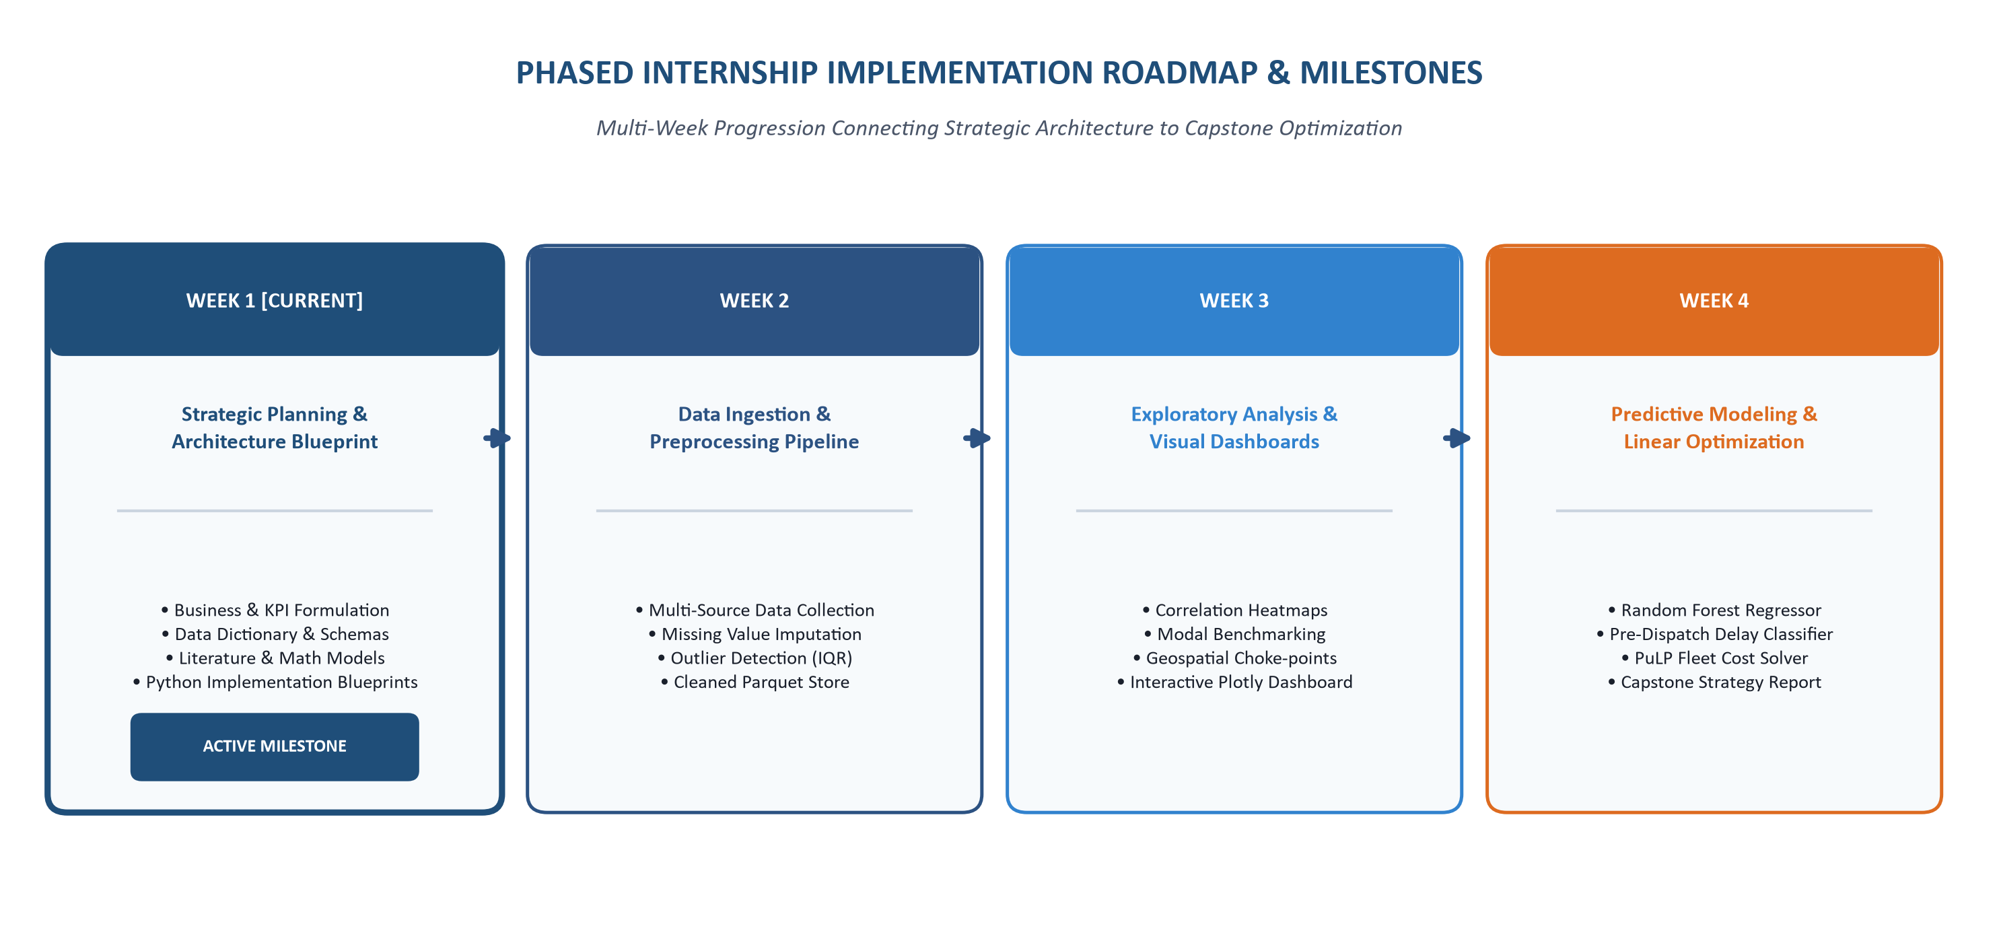
Figure 7: Phased Internship Implementation Roadmap & Milestones
Table 12: Phased Implementation Timeline & Governance Gates
Internship Phase | Core Focus & Workstreams | Key Technical Activities | Phase Deliverables & Milestones
Week 1  [ACTIVE MILESTONE] | Strategic Planning, Architecture & Methodology | Business problem definition, KPI hierarchy design, public data evaluation, Python blueprints | Comprehensive Strategic Report; 7 Visual Diagrams; Data Dictionary; Python blueprints.
Week 2 | Data Ingestion, Cleansing & Pipeline Engineering | Multi-source ingestion, missingness imputation, IQR outlier cleaning, schema validation | Production data cleansing script; audited parquet dataset; cleaning documentation.
Week 3 | Exploratory Data Analysis & Visual Dashboards | Univariate/bivariate EDA, modal benchmarking, geospatial bottleneck isolation, Plotly Dash dashboard | Exploratory analytics report; correlation heatmaps; interactive Plotly dashboard.
Week 4 | Predictive Modeling & Prescriptive Optimization | Feature engineering, TimeSeriesSplit, Random Forest & LightGBM training, PuLP linear solver | Validated regression & classification models; LP dispatch solver; Capstone Report.

28. Success Criteria and Evaluation Framework
To maintain analytical integrity, a clear distinction is maintained between Week 1 proposed success criteria and actual post-implementation outcomes. In this planning phase, success is defined by establishing measurable performance gates across four dimensions:
Table 13: Multi-Dimensional Project Success Evaluation Scorecard
Evaluation Dimension | Evaluation Metric / Gate | Target Planned Threshold | Verification Methodology
Data Quality & Hygiene | Pipeline Data Quality Score | 100% Schema Compliance; 0 Unhandled Nulls | Automated validation assertions executed in Python ingestion pipeline.
Predictive Accuracy (Duration) | Mean Absolute Error (MAE) | MAE < 2.50 Hours on Held-Out Test Set | Evaluated against ground-truth Delivery_Date timestamps on unseen data.
Predictive Goodness-of-Fit | Coefficient of Determination (R²) | R² ≥ 0.85 (Ensemble Models) | Calculated across cross-validation folds on chronological test split.
Delay Risk Classification | Delay Class Precision & Recall | Precision ≥ 80.0%; Recall ≥ 85.0% | Confusion matrix analysis at optimal classification decision threshold.
Cluster Segmentation Cohesion | Mean Silhouette Coefficient | Silhouette Score ≥ 0.55 | Evaluated across K-Means cluster assignments on route feature space.
Optimization Cost Reduction | Simulated Network Cost Savings | 8.0% – 14.0% Direct Transport Savings | Comparative baseline vs. optimized cost simulation in PuLP linear solver.
Operational Dispatcher Adoption | Dispatcher Recommendation Compliance | ≥ 75% Dispatcher Adoption Rate | Post-deployment operational logging of dispatcher routing overrides.

29. Expected Business Outcomes
Upon full execution of the multi-week analytics lifecycle, the enterprise anticipates realizing substantial tangible deliverables and strategic capabilities across its logistics network:
• Operational Outcomes: Targeting an improvement in network-wide On-Time Delivery toward ≥ 95.0%; reducing empty backhaul mileage by an estimated 15%; increasing line-haul vehicle cube utilization toward ≥ 85.0%.
• Financial Outcomes: Targeting an 8% to 14% direct reduction in transportation operating expenditures, yielding an estimated $7.4 Million in recurring annual EBITDA savings potential on a modeled $92.5M freight expenditure base.
• Analytical Outcomes: Deploying an audited, standardized Parquet data lakehouse, sub-2.5-hour ETA forecasting precision, and a 4-tier operational corridor risk segmentation model.
• Decision-Making Outcomes: Transitioning operational management from reactive firefighting toward earlier, data-supported dispatch interventions.
30. Risks, Limitations and Mitigation Strategy
A realistic strategic planning report must identify operational risks, technical vulnerabilities, and data limitations that could impact system implementation:
Table 14: Enterprise Risk Register & Strategic Mitigation Framework
Risk Category | Specific Operational Risk | Impact | Probability | Strategic Mitigation Protocol
Data Sparsity & Missingness | Historical shipping manifests contain missing weights or unrecorded dimensions. | HIGH | MEDIUM | Deploy conditional median imputation conditioned on mode/commodity; flag imputed records.
Exogenous Disruptions | Severe weather storms or highway bridge closures violate historical transit patterns. | HIGH | HIGH | Integrate live NOAA weather APIs and traffic congestion index covariates into feature store.
Algorithmic Data Drift | Seasonal volume surges alter freight patterns, degrading model accuracy. | MEDIUM | HIGH | Implement regular model re-training pipelines; monitor Population Stability Index (PSI).
Dispatcher Adoption Resistance | Experienced dispatchers resist algorithmic recommendations, relying on intuition. | MEDIUM | MEDIUM | Deploy in shadow-mode pilot; measure dispatcher overrides; provide intuitive UI explanations.
Computational Scalability | Large-scale mixed-integer LP solving across thousands of nodes causes latency. | LOW | MEDIUM | Implement cluster-based problem decomposition; solve regional clusters independently.

31. Conclusion and Next-Phase Transition
This Week 1 Strategic Planning and Data Architecture Report establishes the technical, methodological, and operational foundation for the Intelligent Logistics Performance Analytics and Delivery Optimization System. Grounding the project in realistic multi-regional freight operations, this document bridges supply chain operational domain expertise with Python scientific computing, machine learning, and linear programming.
We have articulated a hierarchical Key Performance Indicator (KPI) framework spanning ten core metrics, evaluated public data resources across seven custodians, established a 10-stage end-to-end analytical lifecycle, defined a decoupled 4-tier system architecture, and detailed the mathematical foundations of supervised regression, binary delay classification, unsupervised clustering, and prescriptive linear programming optimization. Furthermore, we have provided seven publication-grade visual architecture diagrams and eight modular Python blueprints utilizing Plotly for interactive visualization, illustrating automated ingestion, profiling, KPI calculation, machine learning modeling, and linear optimization solvers.
As this report fulfills the official Week 1 milestone, all models and pipelines are strategically framed as architectural designs and planning blueprints rather than completed post-execution results. This strategic rigor directly prepares the initiative for Week 2 (Data Collection, Cleansing and Pipeline Preprocessing), Week 3 (Advanced Exploratory Data Analysis and Plotly Dashboarding), and Week 4 (Predictive Model Training and Prescriptive Optimization). Ultimately, the system positions the enterprise to achieve superior delivery velocity, eliminate operational inefficiencies, and establish an evidence-based operational decision framework.
32. Formal Academic References & Industry Literature
Bertsimas, D., & Kallus, N. (2020). From predictive to prescriptive analytics. Management Science, 66(3), 1025-1044.
Chopra, S., & Meindl, P. (2016). Supply Chain Management: Strategy, Planning, and Operation (6th ed.). Pearson Education.
Clarke, G., & Wright, J. W. (1964). Scheduling of vehicles from a central depot to a number of delivery points. Operations Research, 12(4), 568-581.
Dantzig, G. B., & Ramser, J. H. (1959). The truck dispatching problem. Management Science, 6(1), 80-91.
Golden, B., Raghavan, S., & Wasil, E. (Eds.). (2008). The Vehicle Routing Problem: Latest Advances and New Challenges. Springer Science & Business Media.
Govindan, K., Cheng, T. E., Mishra, N., & Shukla, N. (2017). Big data analytics and application for logistics and supply chain management. Computers & Industrial Engineering, 137, 106093.
Speranza, M. G. (2018). Trends in transportation and logistics. European Journal of Operational Research, 264(3), 830-836.
Toth, P., & Vigo, D. (Eds.). (2014). Vehicle Routing: Problems, Methods, and Applications (2nd ed.). SIAM Society for Industrial and Applied Mathematics.
U.S. Department of Transportation. (2022). Freight Analysis Framework (FAF5): Multi-Modal Freight Flows and Commodity Trends. Bureau of Transportation Statistics.
Wang, Y., Zhang, D., Liu, Q., Shen, F., & Lee, L. H. (2020). Towards enhancing the predictability of freight transportation transit times: A machine learning approach. Transportation Research Part E: Logistics and Transportation Review, 142, 102073.
33. Appendix: Mathematical Nomenclature & Symbol Glossary
Table 15: Mathematical Optimization Nomenclature & Symbol Glossary
Symbol | Parameter / Variable Name | Domain & Units | Operational Role in Mathematical Model
X_ijm | Decision Variable | Non-Negative Integer (Units) | Consignment freight units shipped from Origin Hub i to Destination Hub j via Mode m.
C_ijm | Unit Cost Coefficient | USD ($) per Consignment | Direct transportation expenditure incurred per unit shipped between hub i and j via mode m.
D_j | Destination Demand | Freight Units (Consignments) | Total required inbound freight demand volume at destination hub facility j.
S_i | Origin Hub Capacity | Freight Units (Consignments) | Maximum outbound dispatch capacity available at origin terminal facility i.
CAP_m | Modal Fleet Capacity | Kilograms / Cubic Meters | Physical vehicle fleet payload capacity constraint for transportation mode m.
T_ijm | Transit Duration Function | Elapsed Decimal Hours | Predicted or actual elapsed transit duration between nodes i and j via mode m.
SLA_j | Service Level Agreement | Elapsed Hours Threshold | Maximum allowable contractual delivery time committed to customer at destination j.
Z | Objective Function Value | Total USD ($) | Total network transportation expenditure minimized by the linear programming solver.

